13.2.7 Reference Windows

This Window section contains the following Reference subsystem functional groups and a brief description of each.

- The Claim Exception Functional Group contains windows that allow the user to inquire on claim exception code information.
- The Therapeutic Groups Functional Group contains windows that allow the user to inquire on therapeutic grouping information.
- The Drug Program Functional Group contains windows that allow the user to inquire on drug program information
- The Step Care Functional Group contains windows that allow the user to inquire on step care information.
- The Inferred Disease Functional Group contains windows that allow the user to inquire on inferred disease information.
- The DUR Functional Group contains windows that allow the user to inquire on DUR information.

Each of these is described in detail separately, beginning below.

Note: Reference subsystem data is intended for Conduent internal use in managing customer programs. For New Mexico, change requests for Reference subsystem information and settings may be made via PCR requests in the production system. The Conduent Functional Application Support Team (FAST) is responsible for making the appropriate changes within PDCS OS PLUS.

13.2.7.3 Claim Exception Codes Functional Group

This functional group provides the user the ability to:

- Inquire on Claim Exception Codes

The following tab windows are used by the Claim Exception Functional Group:

- Search
- Claim Exception
- Claim Disposition

The following data is displayed in the title bar of all tab windows (i.e., not on search windows) in this functional group:

- Customer Name
- Claim Exception Code is displayed on the Claim Exception and Claim Disposition Tab pages

New Mexico PDCS OS PLUS Reference Subsystem
Window Specification
Claim Exception Functional Group
Search Tab Page

Window Name: Claim Exception: Search
Description:

The Search window is the first window that appears when the Claim Exception Codes section is selected from the PDCS OS PLUS Reference Subsystem Menu. The user may enter selection criteria to locate an existing claim exception code.

A claim exception code search can be performed by using various search criteria. Search criteria include Claim exception code, EOB Code, NCPDP Reject, or Customer Exceptions. A partial information search can also be performed using three or more characters followed by a wild card (%).

If only one claim exception code record matches the search criteria entered, that record is displayed on the Claim Exception information window.

Window Type: Response window
Navigation:
The user enters this window by clicking on the Search tab while in the Claim Exception Code functional group of the Reference subsystem.

Interface to Other Subsystem(s):
N/A

Interface to Other Application(s):
N/A

Special Security Requirements:
Add, Update, and Delete functionality is restricted to authorized users.
Presentation Sequence(s):
N/A

Remarks:
N/A
New Mexico PDCS OS PLUS Reference Subsystem
Window Layout
Claim Exception Functional Group
Search Tab Page

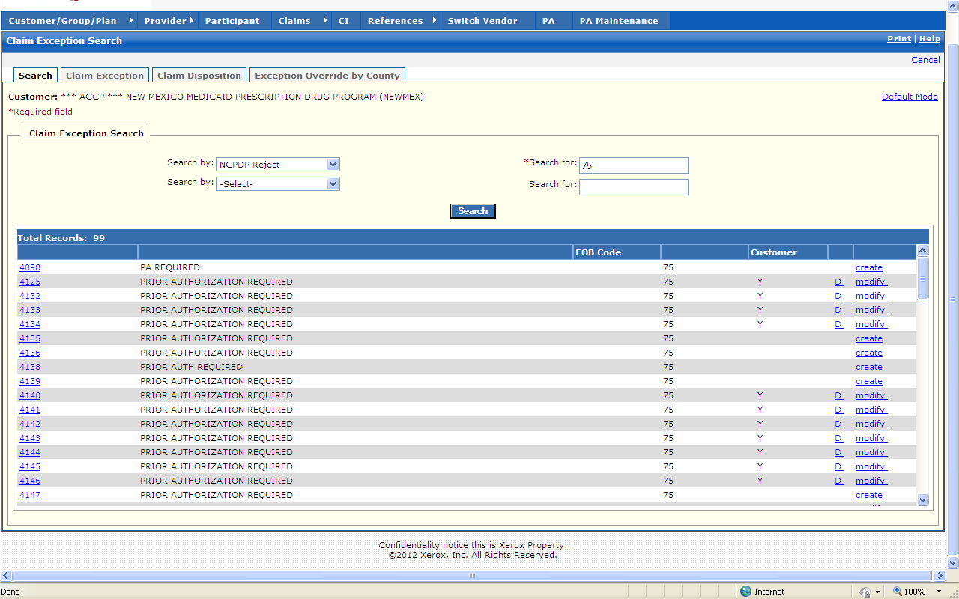

New Mexico PDCS OS PLUS Reference Subsystem
Window Exhibit
Claim Exception Functional Group
Search Tab Page
Field Name | Table Column Name | Table Name | Format | Prot. (A,C,N) | Req.  (A,C,N) | Std. Edits | Specifications | Note  Ref.
Customer | R_CUST_NAM & R_CUST_ID | R_CUST_DTL_TB | Display | A | N | N/A | This field is populated based on the Customer ID chosen upon login.
Default Mode | N/A | N/A | Link | N | N | N/A
Claim Exception Search | N/A | N/A | N/A | N/A | N/A | N/A | Grouping
Search by (1) | N/A | N/A | Drop-down | N | N | N/A | Search by defaults to Claim Exception Code. EOB Code, NCPDP Reject, Customer Exceptions are the other Search by options.
Search by (2) | N/A | N/A | Drop-down | N | N | V | EOB Code, NCPDP Reject, Customer Exceptions are the secondary Search by options.  VALID VALUES 1737
Search for (1) | N/A | N/A | N/A | N | A | N/A | Required Field. Wild card (%) search can be invoked using 3 characters and a wild card (%).
Search for (2) | N/A | N/A | N/A | N | N | V | Required Field. Wild card (%) search can be invoked using 3 characters and a wild card (%).
Command Button | Group | N/A | Button Row | N/A | N/A | N/A | Grouping
Search | N/A | N/A | Push Button | N | N | N/A | When selected this button searches the reference database to match the criteria entered in the Search By and the Search For criteria fields.
Search Results Display | Group | N/A | Button Row | N/A | N/A | N/A | Grouping
Claim Excep Code | R_CLM_EXC_CD | RCEEXCTB | X(4) | A | N | N/A
Description | R_EXC_SHORT_DESC | RCEEXCTB | X(30) | A | N | N/A
EOB Code | R_TXT_EOB_CD | RCEEXCTB | X(4) | A | N | N/A
NCPDP Reject | R_CLM_ADJUD_REJ_CD | RCEEXCTB | X(3) | A | N | N/A
Customer | R-CUST-PART-NUM | RCEDS2TB | 9,999 | A | N | N/A | Display Header | R1
Total Records | N/A | N/A | Display | A | N | N/A | Computed as total number of records meeting the search criteria.

Legend
Prot. and Req. | Standard Edits | Note Ref.
A = Always | D = Date Edit | C = Customer-specific field or functionality
C = Conditionally | N = Numeric Edits | R = Note Reference
N = Never | S = System Generated
 | V = Valid Value Edit

Ref. No. | Notes
R1 | The “Customer” header has three columns under it:  - Column 1 - Customer Specific edits, if this column contains a “Y” then this edit is a Customer Specific edit.  - Column 2 – Delete Customer Specific edit, if this column contains a “D”, then the Customer Specific edit can be deleted by clicking on the “D”.  - Column 3 – Allows for modifying or creating Customer Specific edits. “Modify” in this column indicates an existing Customer Specific edit which can be updated by clicking on “Modify”. “Create” in this column indicates this is not a Base edit which can be made a Customer Specific edit by clicking “Create” and completing the subsequent windows.

New Mexico PDCS OS PLUS Reference Subsystem
Window Specification
Claim Exception Functional Group
Claim Exception Tab Page

Window Name: Claim Exception: Claim Exception
Description:
The Claim Exception window appears after selecting a specific claim exception code from the search results list.

The Claim Exception window is used to display detail information about the claim exception code selected. The detail information includes: begin and end date, corresponding EOB Code, corresponding NCPDP reject code information, override indicators, and message text that is sent back to the pharmacy.

Window Type: Response window
Navigation:
The user enters this window by selecting a specific claim exception code from the search results list after performing a search. The Claim Exception Code window is located within the Claim Exception Code functional group within the Reference Subsystem.

Interface to Other Subsystem(s):
N/A

Interface to Other Application(s):
N/A

Special Security Requirements:
Add, Update, and Delete functionality is restricted to authorized users.

Presentation Sequence(s):
N/A

Remarks:
N/A

New Mexico PDCS OS PLUS Reference Subsystem
Window Layout
Claim Exception Functional Group
Claim Exception Tab Page

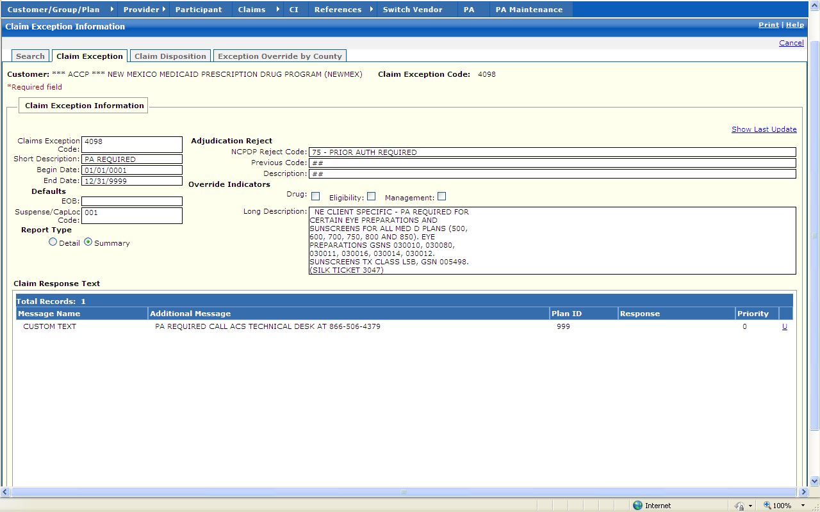

New Mexico PDCS OS PLUS Reference Subsystem
Window Exhibit
Claim Exception Functional Group
Claim Exception Tab Page
Field Name | Table Column Name | Table Name | Format | Prot. (A,C,N) | Req.  (A,C,N) | Std. Edits | Specifications | Note  Ref.
Customer | R_CUST_NAM & R_CUST_ID | R_CUST_DTL_TB | Display | A | N | N/A | This field is populated based on the Customer ID chosen upon login.
Claim Exception Code | R_CLM_EXC_CD | RCEEXCTB | X(4) | A | N | N/A | Display Header
Claim Exception Information | Group | N/A | Free Form | N/A | N/A | N/A | Grouping
Show Last Update | G_AUD_USER_ID, G_AUD_TS | RCEEXCTB | X(8),  TIMESTAMP | A | N | N/A | By selecting the Show Last Update Link, a pop-up window is displayed showing User ID, Date and Time of when the record was initially created, and when it was last updated.
Claim Exception Code | R_CLM_EXC_CD | RCEEXCTB | X(4) | A | N | N/A
Short Description | R_EXC_SHORT_DESC | RCEEXCTB | X(30) | A | N | N/A
Begin Date | R_CLM_EXC_BEG_DT | RCEEXCTB | DATE | A | C | D | Must be a valid date
End Date | R_CLM_EXC_END_DT | RCEEXCTB | DATE | A | C | D | Must be a valid date
Defaults | Group | N/A | Free Form | N/A | N/A | N/A | Grouping
EOB | R_TXT_EOB_CD | RCEEXCTB | X(4) | A | N | N/A
Suspense/  CapLoc Code | R_TXT_LOCN_CD | RCEEXCTB | X(3) | A | N | N/A
Report Type | Group | N/A | Free Form | N/A | N/A | N/A | Grouping
Detail | N/A | N/A | Radio Button | N | N | N/A | Detail Report Indicator
Summary | N/A | N/A | Radio Button | N | N | N/A | Summary Report Indicator
Adjudication Reject | Group | N/A | Free Form | N/A | N/A | N/A | Grouping
NCPDP Reject Code | R_CLM_ADJUD_REJ_CD | RCEEXCTB | X(3) | A | N | N/A
Previous Code | R_PRV_VRSN_REJ_CD | RCEEXCTB | X(2) | A | N | N/A
Description | R_PRV_VRSN_RJ_DESC | RCEEXCTB | X(30 | A | N | N/A
Override Indicators | Group | N/A | Free Form | N/A | N/A | N/A | Grouping
Drug | R_DRUG_OVERRID_IND | RCEEXCTB | X(1)  Check Box | N | N | N/A | Check Box
Eligibility | R_ELIG_OVERRID_IND | RCEEXCTB | X(1)  Check Box | N | N | N/A | Check Box
Management | R_MGMT_OVERRID_IND | RCEEXCTB | X(1)  Check Box | N | N | N/A | Check Box
Long Description | R_EXC_LONG_DESC | RCEEXCTB | X(320) | N | N | N/A | Text box
Claim Response Text Display | Group | N/A | Free Form | N/A | N/A | N/A | Grouping
Message Name | R_NCPDP_MSG_DESC | RCERSPTB | X(50) | A | N | N/A | Internal message label
Additional Message | R_NCPDP_MSG_TX | RCERSPTB | X(175) | A | N | N/A
Plan ID | R_SEQ_NUM | RCERSPTB | 9(4) COMP (4 bytes) | A | N | N/A
Response | R_ADDL_RESP_MSG_CD | RCERSPTB | X(2) | A | N | N/A
Priority | R_TYP_PRIORITY_NUM | RCERSPTB | Small integer (1 byte) | A | N | N/A
Total Records | N/A | N/A | Display | A | N | N/A | Computed

Legend
Prot. and Req. | Standard Edits | Note Ref.
A = Always | D = Date Edit | C = Customer-specific field or functionality
C = Conditionally | N = Numeric Edits | R = Note Reference
N = Never | S = System Generated
 | V = Valid Value Edit

Ref No. | Notes
N/A | N/A
New Mexico PDCS OS PLUS Reference Subsystem
Window Specification
Claim Exception Functional Group
Claim Disposition Tab Page

Window Name: Claim Exception: Claim Disposition
Description:
The Claim Disposition window appears after selecting a specific claim exception code from the search results list, and then clicking on the Claim Disposition tab while in the Claim Exception Code functional group of the Reference subsystem.

The Claim Disposition window shows if the claim is set to deny, pay, or suspend. Dispositions are specific to claim and media type, such that exam entered claims may have a different disposition versus point of sale claims. This window also shows if an edit can be forced to pay or forced to deny.

Window Type: Response window
Navigation:
The user enters this window by clicking on the Claim Disposition tab while in the Claim Exception Code functional group of the Reference subsystem, after selecting a specific claim exception code.

Interface to Other Subsystem(s):
N/A

Interface to Other Application(s):
N/A

Special Security Requirements:
Add, Update, and Delete functionality is restricted to authorized users.

Presentation Sequence(s):
N/A

Remarks:
N/A

New Mexico PDCS OS PLUS Reference Subsystem
Window Layout
Claim Exception Functional Group
Claim Disposition Tab Page

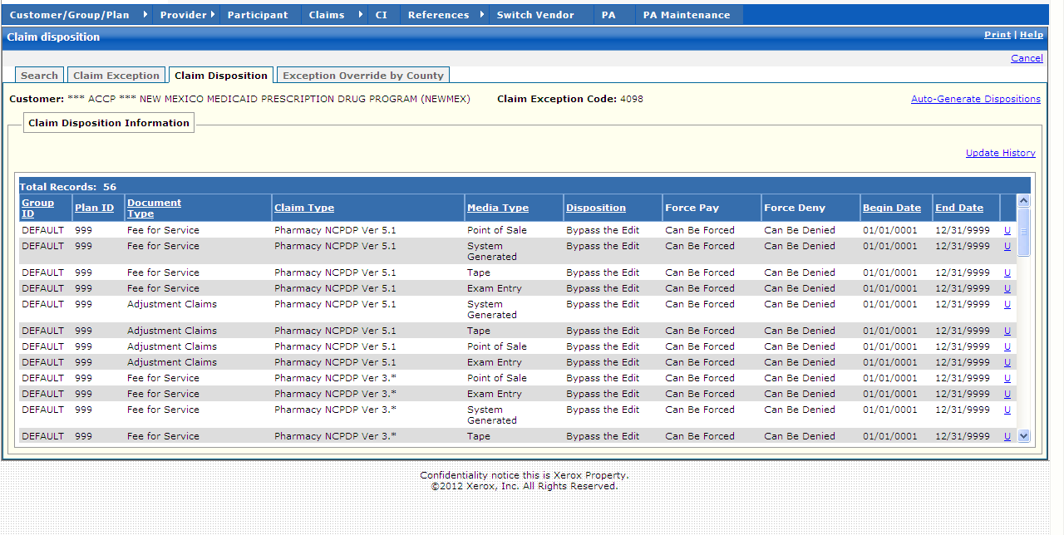

New Mexico PDCS OS PLUS Reference Subsystem
Window Exhibit
Claim Exception Functional Group
Claim Disposition Tab Page
Field Name | Table Column Name | Table Name | Format | Prot. (A,C,N) | Req.  (A,C,N) | Std. Edits | Specifications | Note  Ref.
Customer | R_CUST_NAM & R_CUST_ID | R_CUST_DTL_TB | Display | A | N | N/A | This field is populated based on the Customer ID chosen upon login.
Claim Exception Code | R_CLM_EXC_CD | RCEEXCTB | X(4) | A | N | N/A | Display Header
Auto-Generate Dispositions | N/A | N/A | Link | A | N | N/A | When selected, a new window opens for the Auto-Generate Dispositions page
Claim Disposition Information Display | Group | N/A | Free Form | N/A | N/A | N/A | Grouping
Group ID | R_GROUP_ID | RCEDS2TB | X(8) | A | N | N/A
Plan ID | R_PLAN_ID | RCEDS2TB | X(3) | A | N | N/A
Document Type | C_BAT_DOC_TY_CD | RCEDS2TB | X(1) | A | N | N/A
Claim Type | C_HDR_TY_CD | RCEDS2TB | X(1) | A | N | N/A
Media Type | C_BAT_MED_SRC_CD | RCEDS2TB | X(1) | A | N | N/A
Disposition | R_CLM_EXC_DISP_CD | RCEDS2TB | X(1) | A | N | N/A
Force Pay | R_EXC_FORCE_APP_CD | RCEDS2TB | X(1) | A | N | N/A
Force Deny | R_FORCE_DENY_CD | RCEDS2TB | X(1) | A | N | N/A
Begin Date | R_CLM_EXC_BEG_DT | RCEDS2TB | DATE | A | N | N/A
End Date | R_CLM_EXC_END_DT | RCEDS2TB | DATE | A | N | N/A
Total Records | N/A | N/A | Display | A | N | N/A | Computed

Legend
Prot. and Req. | Standard Edits | Note Ref.
A = Always | D = Date Edit | C = Customer-specific field or functionality
C = Conditionally | N = Numeric Edits | R = Note Reference
N = Never | S = System Generated
 | V = Valid Value Edit

Ref No. | Notes
N/A | N/A
New Mexico PDCS OS PLUS Reference Subsystem
Window Specification
Claim Exception Functional Group
Claim Disposition: Auto-Generate Tab Page

Window Name: Claim Exception: Claim Disposition: Auto-Generate
Description:

The Claim Disposition: Auto-Generate window is used to set the Disposition for a claim exception code. The options for Disposition are:
- Bypass
- Deny & Rpt
- Deny
- Suspend
- Super Suspend
- Pay & Rpt
- Pay
- Reject
- Ignore

Window Type: Response window
Navigation: The user enters this window by selecting the Auto-Generate link from the Claims Disposition window

Interface to Other Subsystem(s):
N/A

Interface to Other Application(s):
N/A

Special Security Requirements:
Add, Update, and Delete functionality is restricted to authorized users.

Presentation Sequence(s):
N/A

Remarks:
N/A
New Mexico PDCS OS PLUS Reference Subsystem
Window Layout
Claim Exception Functional Group
Claim Disposition: Auto-Generate Tab Page

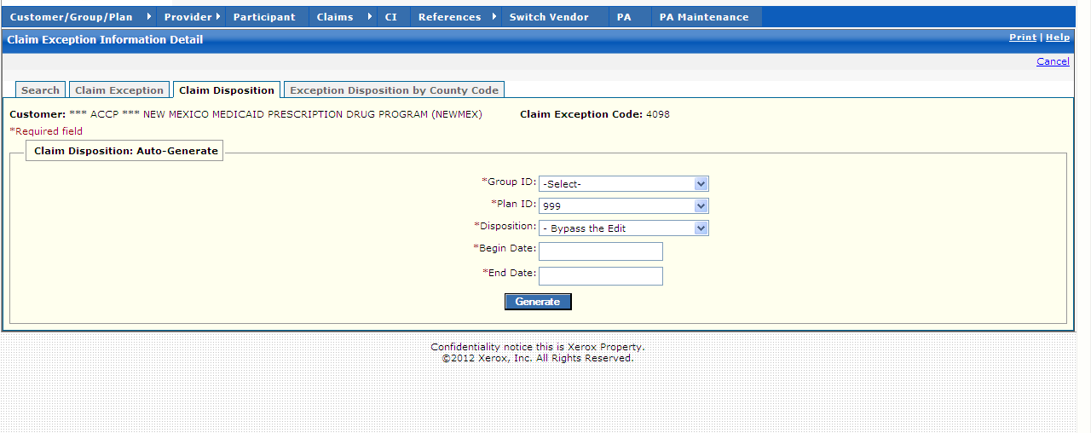

New Mexico PDCS OS PLUS Reference Subsystem
Window Exhibit
Claim Exception Functional Group
Claim Disposition: Auto-Generate Tab Page
Field Name | Table Column Name | Table Name | Format | Prot. (A,C,N) | Req. (A,C,N) | Std. Edits | Specifications | Note  Ref.
Customer | R_CUST_NAM & R_CUST_ID | R_CUST_DTL_TB | Display | A | N | N/A | This field is populated based on the Customer ID chosen upon login.
Claim Exception Code | R_CLM_EXC_CD | RCEEXCTB | X(4) | A | N | N/A
Claim Disposition: Auto-Generate | Group | N/A | Free Form | N/A | N/A | N/A | Grouping
Group ID | R_GROUP_ID | RCEDS2TB | X(8)  Drop-down | N | A | N/A
Plan ID | R_PLAN_ID | RCEDS2TB | X(3)  Drop-down | N | A | N/A
Disposition | R_CLM_EXC_DISP_CD | RCEDS2TB | X(1)  Drop-down | N | A | V | VALID VALUES 0156
Begin Date | R_CLM_EXC_BEG_DT | RCEDS2TB | DATE | A | A | D | Must be a valid date
End Date | R_CLM_EXC_END_DT | RCEDS2TB | DATE | A | A | D | Must be a valid date
Command Button | Group | N/A | Button Row | N/A | N/A | N/A | Grouping
Generate | N/A | N/A | Push Button | N | N | N/A

Legend
Prot. and Req. | Standard Edits | Note Ref.
A = Always | D = Date Edit | C = Customer-specific field or functionality
C = Conditionally | N = Numeric Edits | R = Note Reference
N = Never | S = System Generated
 | V = Valid Value Edit

Ref. No. | Notes
N/A | N/A

New Mexico PDCS OS PLUS Reference Subsystem
Window Specification
Claim Exception Functional Group
Exception Override by County Tab Page

Window Name:
Exception Override by County
Description:
The Exception Override by County appears when you select the Claim Exception codes link from the Reference tab.

Note: The Exception Override by County functional group is not currently utilized for New Mexico.

Window Type:
Display window
Navigation:
N/A
Interface to Other Subsystem(s):
N/A
Interface to Other Application(s):
N/A
Special Security Requirements:
N/A
Presentation Sequence(s):
N/A
Remarks:
N/A

New Mexico PDCS OS PLUS Reference Subsystem
Window Layout
Claim Exception Functional Group
Exception Override by County Tab Page

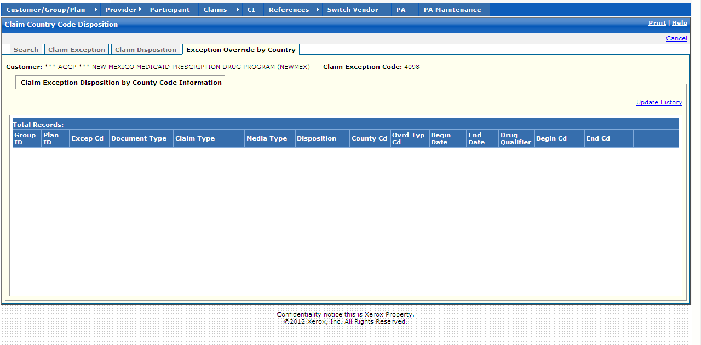

13.2.7.4 Therapeutic Groups Functional Group

This functional group provides the user the ability to:

- Inquire on therapeutic class grouping information

Note: The Therapeutic Groups functional group is not currently utilized for New Mexico. For this reason, Window Exhibits are not provided for this functional group.

New Mexico PDCS OS PLUS Reference Subsystem
Window Specification
Therapeutic Groups Functional Group
Therapeutic Groups Window Page

Window Name:
Therapeutic Groups
Description:
The Therapeutic Groups window is the first window that appears when the Therapeutic Groups functional group is selected from the Reference subsystem menu. Any existing Therapeutic Groups display automatically.

Note: The Therapeutic Groups functional group is not currently utilized for New Mexico.

Window Type:
Response window
Navigation:
The user enters this window by clicking the Reference option on the PDCS OS PLUS menu, then clicking the Therapeutic Groups option. This displays the Therapeutic Groups window. The user may add a new group or may select a group for detail viewing and therapeutic class addition or deletion by clicking on the Group Name link.
Interface to Other Subsystem(s):
N/A
Interface to Other Application(s):
N/A
Special Security Requirements:
Add, Update, and Delete functionality is restricted to authorized users.
Presentation Sequence(s):
Therapeutic Groups are presented by Group Name order.
Remarks:
N/A
New Mexico PDCS OS PLUS Reference Subsystem
Window Layout
Therapeutic Groups Functional Group
Therapeutic Groups Window

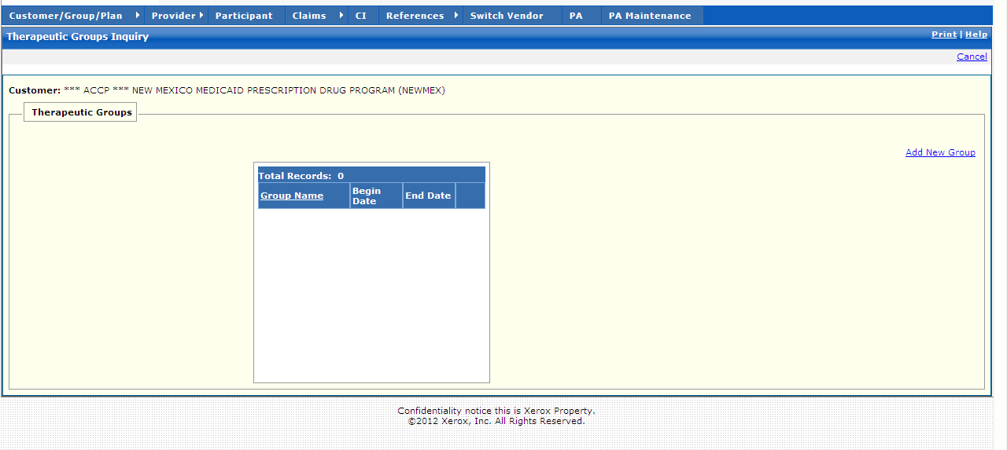

New Mexico PDCS OS PLUS Reference Subsystem
Window Specification
Therapeutic Groups Functional Group
Add Therapeutic Group Window

Window Name:
Therapeutic Groups: Add Therapeutic Group
Description:
The Add Therapeutic Group window appears after clicking the Add New Group link.

The Add Therapeutic Group window is used to create a new Therapeutic Group and add specific therapeutic classes.

Note: The Therapeutic Groups functional group is not currently utilized for New Mexico.

Window Type:
Response window
Navigation:
The user enters this window by clicking the Add New Group link.
Interface to Other Subsystem(s):
N/A
Interface to Other Application(s):
N/A
Special Security Requirements:
Add, Update, and Delete functionality is restricted to authorized users.
Presentation Sequence(s):
N/A
Remarks:
N/A

New Mexico PDCS OS PLUS Reference Subsystem
Window Layout
Therapeutic Groups Functional Group
Add Therapeutic Group Window

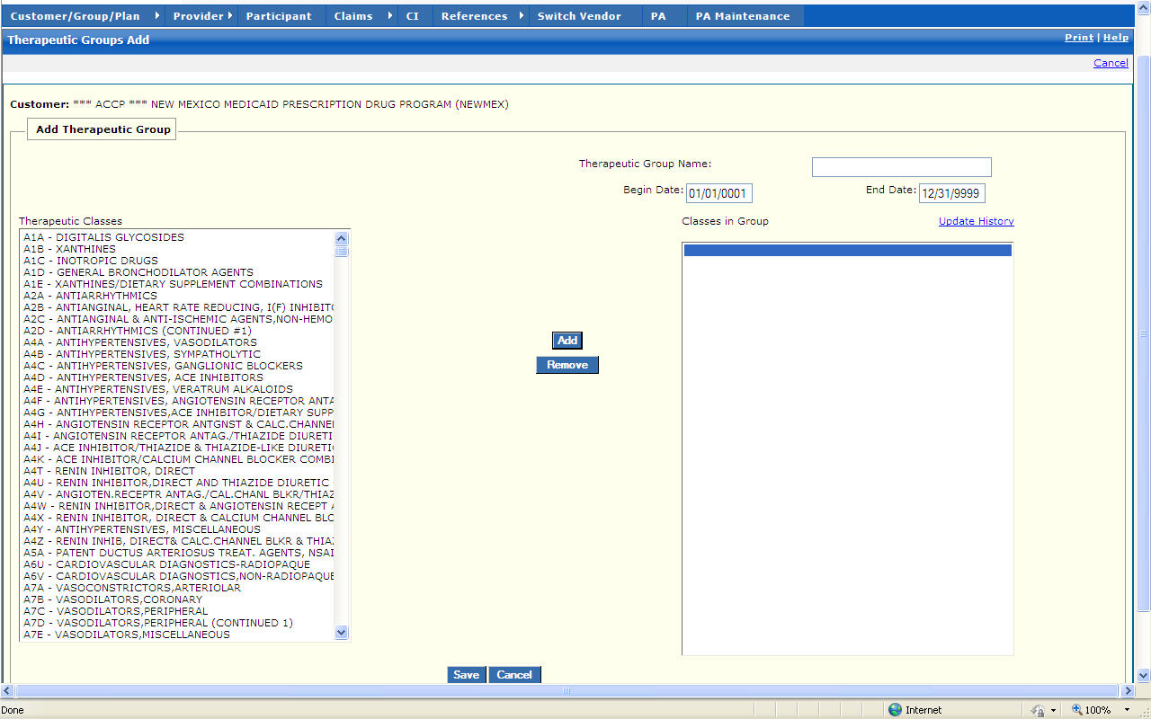
New Mexico PDCS OS PLUS Reference Subsystem
Window Specification
Therapeutic Groups Functional Group
Edit Therapeutic Group Window

Window Name:
Therapeutic Groups: Edit Therapeutic Group
Description:
The Edit Therapeutic Group window appears after selecting a specific Therapeutic Groups record from the Therapeutic Groups list.

The Edit Therapeutic Group window is used to add or remove specific therapeutic classes from a Therapeutic Group.

Note: The Therapeutic Groups functional group is not currently utilized for New Mexico.

Window Type:
Response window
Navigation:
The user enters this window by selecting a specific Therapeutic Group record from the list by clicking its Group Name link.
Interface to Other Subsystem(s):
N/A
Interface to Other Application(s):
N/A
Special Security Requirements:
Add, Update, and Delete functionality is restricted to authorized users.
Presentation Sequence(s):
N/A
Remarks:
N/A

New Mexico PDCS OS PLUS Reference Subsystem
Window Layout
Therapeutic Groups Functional Group
Edit Therapeutic Group Window

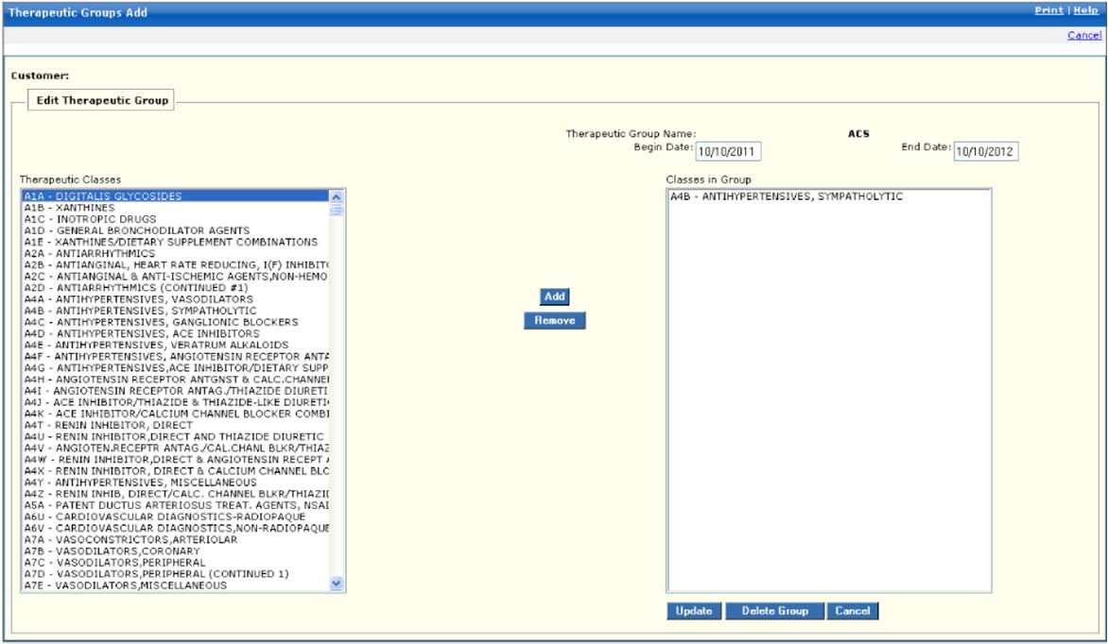

13.2.7.5 Drug Program Functional Group

This functional group provides the user the ability to:

- Inquire on Drug Program information

The following tab windows are used by the Drug Program Functional Group:

- Search
- Program
- Detail Select
- Detail
- NDC

The following data is displayed in the title bar of all tab windows (i.e., not on search windows) in this functional group:

- Customer Name
- Program data displays only on the Detail Select Tab Window, Detail Tab Window, and NDC Window.
- Line data displays only on the Detail Tab Window.
- Begin Date displays only on the Detail Select Tab Window, Detail Tab Window, and NDC Window.
- End Date displays only on the Detail Select Tab Window, Detail Tab Window, and NDC Window.

New Mexico PDCS OS PLUS Reference Subsystem
Window Specification
Drug Program Functional Group
Search Tab Page

Window Name:
Drug Program: Search

Description:
The Search window is the first window that appears when the Drug Program functional group is selected from the PDCS OS PLUS Reference Subsystem Menu. The user may select to add a new Drug program or enter selection criteria to locate an existing Drug program.

A Drug Program search can be performed using Drug Program Code, Description, or NDC.

If only one Drug Program record matches the search criteria entered, that record is displayed on the Program tab.

If multiple records match the search criteria, the first 500 records displays in the Drug Program Search list box. The user may scroll through the list of programs until the desired program is located. To select a program for display, the user must click the Drug Program Code link.

Window Type:
Response window

Navigation:
The user enters this window by selecting the Reference subsystem on the menu bar, and then selecting Drug Program from the drop-down list of functional groups.

Interface to Other Subsystem(s):
N/A

Interface to Other Application(s):
N/A

Special Security Requirements:
Add, Update, and Delete functionality is restricted to authorized users.

Presentation Sequence(s):
The Search By criteria determines the initial sequence of data presented. The search results may be resorted into Drug Program Code or Description by clicking on the column heading.
Remarks:
N/A

New Mexico PDCS OS PLUS Reference Subsystem
Window Layout
Drug Program Functional Group
Search Tab Page

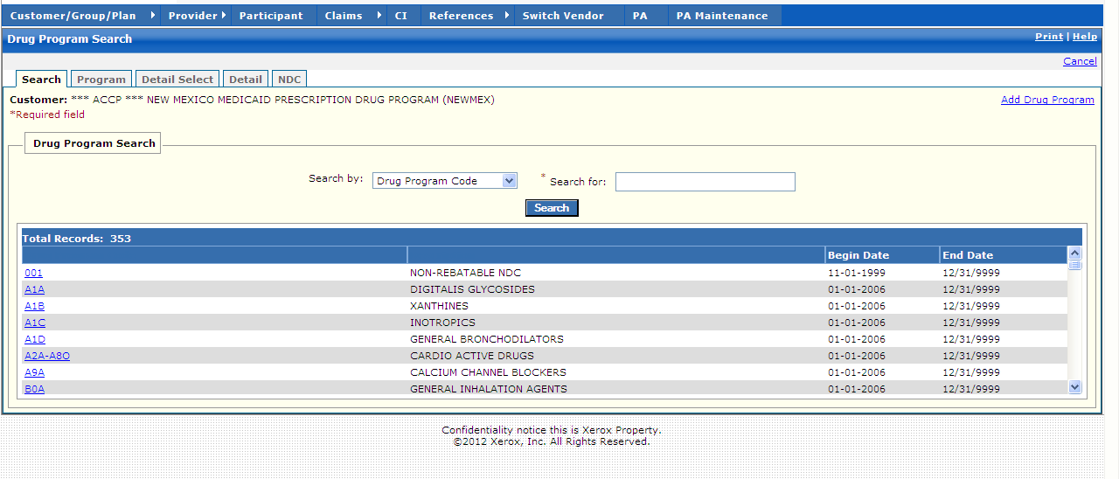

New Mexico PDCS OS PLUS Reference Subsystem
Window Exhibit
Drug Program Functional Group
Search Tab Page
Field Name | Table Column Name | Table Name | Format | Prot. (A,C,N) | Req.  (A,C,N) | Std. Edits | Specifications | Note  Ref.
Customer | R_CUST_NAM & R_CUST_ID | R_CUST_DTL_TB | Display | A | N | N/A | This field is populated based on the Customer ID chosen upon login.
Add Drug Program | N/A | N/A | Link | N/A | N/A | N/A | When selected, a blank Program tab window is opened to create a new Drug Program.
Drug Program Search Display | Group | N/A | Grid | N/A | N/A | N/A | Grouping
Drug Program Code | A_PA_PROG_CD | TBD | X (12) | A | N | N/A
Description | A_PA_PROG_DESC | A_PROG_DESC_TB | X (30) | A | N | N/A
Begin Date | A_PA_PROG_BEG_DT | A_PROG_DESC_TB | DATE | A | N | N/A |  | R1
End Date | A_PA_PROG_END_DT | A_PROG_DESC_TB | DATE | A | N | N/A |  | R1
Total Records | N/A | N/A | Display | A | N | N/A | Computed
Drug Program Search Entry | Group | N/A | Free Form | N/A | N/A | N/A | Grouping
Search by | N/A | N/A | Drop-down | N | N | V | Search default: Drug Code Program. Other search values: NDC and Description.  16D_04_6pdb.doc#A_PA_PROG_CD
Search for | N/A | N/A | N/A | N | A | N/A | This field is required. A % can be used as a wildcard along with 3 characters.
Command Button | Group | N/A | Button Row | N/A | N/A | N/A | Grouping
Search | N/A | N/A | Push Button | N | N | N/A | When selected, this button searches the Drug Code Program database to match the criteria entered in the Search By and the Search For criteria fields.

Legend
Prot. and Req. | Standard Edits | Note Ref.
A = Always | D = Date Edit | C = Customer-specific field or functionality
C = Conditionally | N = Numeric Edits | R = Note Reference
N = Never | S = System Generated
 | V = Valid Value Edit

Ref. No. | Notes
R1 | End Date must be greater than Begin Date. If not, the following error message is displayed: “The End Date is before the Begin Date. Change one of the Dates.”

New Mexico PDCS OS PLUS Reference Subsystem
Window Specification
Drug Program Functional Group
Program Tab Page

Window Name:
Drug Program: Program

Description:
The Program window displays the Drug Program Definition, which includes program code, program description, begin date, and end date.

Window Type:
Response window

Navigation:
The user enters this window by selecting the PDCS OS PLUS Reference subsystem on the menu bar, and then selecting Drug Program from the drop-down list of functional groups. The user then selects a Drug Program from the Drug Program Search Window results.

Interface to Other Subsystem(s):
N/A

Interface to Other Application(s):
N/A

Special Security Requirements:
Add, Update, and Delete functionality is restricted to authorized users.

Presentation Sequence(s):
N/A

Remarks:
N/A

New Mexico PDCS OS PLUS Reference Subsystem
Window Layout
Drug Program Functional Group
Program Tab Page

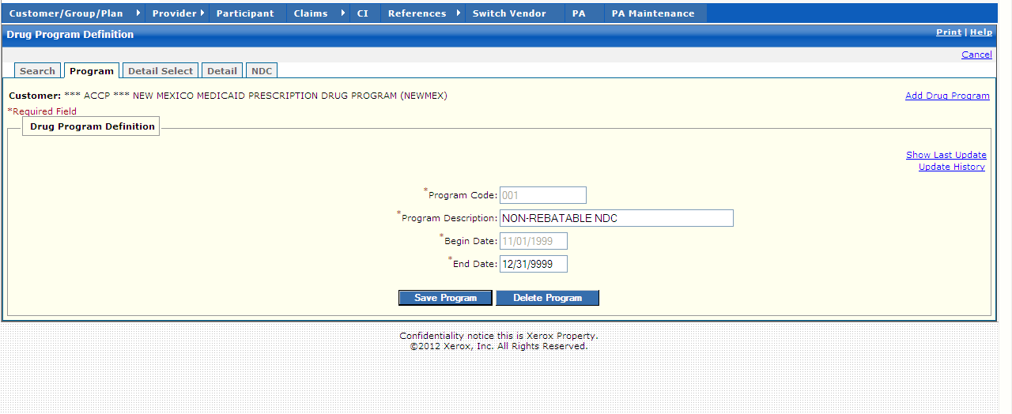

New Mexico PDCS OS PLUS Reference Subsystem
Window Exhibit
Drug Program Functional Group
Program Tab Page
Field Name | Table Column Name | Table Name | Format | Prot. (A,C,N) | Req.  (A,C,N) | Std. Edits | Specifications | Note  Ref.
Customer | R_CUST_NAM & R_CUST_ID | R_CUST_DTL_TB | Display | A | N | N/A | This field is populated based on the Customer ID chosen upon login.
Add Drug Program | N/A | N/A | Link | N | N | N/A | When selected, new window is opened to create a new Drug Program.
Drug Program Definition | N/A | N/A | Free Form | N/A | N/A | N/A | Grouping
Show Last Update | G_AUD_USER_ID, G_AUD_TS | A_PROG_DESC_TB | X (20),  TIMESTAMP | N | N | N/A | By selecting the Show Last Update Link, a pop-up window is displayed showing User ID, Date and Time of when the record was last updated.
Program Code | A_PA_PROG_CD | A-PA-HEADER-TB | X(12) | N | A | N/A
Program Description | A_PA_PROG_DESC | A_PROG_DESC_TB | Link | N | A | N/A
Begin Date | A_PA_PROG_BEG_DT | A_PROG_DESC_TB | DATE | A | A | D | This field is always required if any other data is entered on the row.  Format is MM/DD/CCYY. Must be a valid date. | R1
End Date | A_PA_PROG_END_DT | A_PROG_DESC_TB | DATE | A | A | D | This field is always required if any other data is entered on the row.  Format is MM/DD/CCYY. Must be a valid date. | R1
Command Buttons | Group | N/A | Button Row | N/A | N/A | N/A | Grouping
Save Program | N/A | N/A | Push Button | N | N | N/A
Delete Program | N/A | N/A | Push Button | N | N | N/A

Legend
Prot. and Req. | Standard Edits | Note Ref.
A = Always | D = Date Edit | C = Customer-specific field or functionality
C = Conditionally | N = Numeric Edits | R = Note Reference
N = Never | S = System Generated
 | V = Valid Value Edit

Ref. No. | Notes
R1 | End Date must be greater than Begin Date. If not, the following error message is displayed: “The End Date is before the Begin Date. Change one of the Dates.”

New Mexico PDCS OS PLUS Reference Subsystem
Window Specification
Drug Program Functional Group
Detail Select Tab Page

Window Name:
Drug Program: Detail Select

Description:
The Detail Select window displays a list of Drug Program details and applicable plans that are available for selection. The user may create a new Drug Program Detail line by clicking on the Add Detail link.

Window Type:
Response window

Navigation:
The user enters this window by selecting a Drug Program from the list in the Search window, and then clicking on the Detail Select tab within the Drug Program functional group of the Reference subsystem.

Interface to Other Subsystem(s):
N/A

Interface to Other Application(s):
N/A

Special Security Requirements:
Add, Update, and Delete functionality is restricted to authorized users.

Presentation Sequence(s):
N/A

Remarks:
N/A

New Mexico PDCS OS PLUS Reference Subsystem
Window Layout
Drug Program Functional Group
Detail Select Tab Page

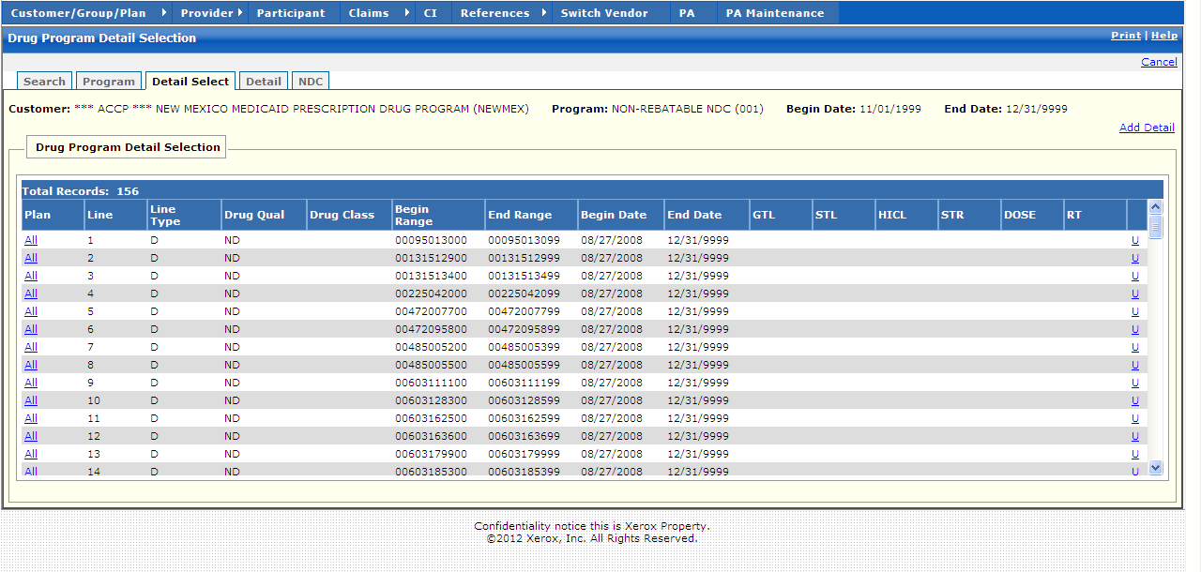

New Mexico PDCS OS PLUS Reference Subsystem
Window Exhibit
Drug Program Functional Group
Detail Select Tab Page
Field Name | Table Column Name | Table Name | Format | Prot. (A,C,N) | Req.  (A,C,N) | Std. Edits | Specifications | Note  Ref.
Customer | R_CUST_NAM & R_CUST_ID | R_CUST_DTL_TB | Display | N | N | N/A | This field is populated based on the Customer ID chosen upon login.
Program | A_PA_PROG_CD | A_PROG_DESC_TB | Display | N | N | N/A | This field is populated based on Drug Program chosen.
Begin Date | A_LI_BEG_DT | A_PROG_DEF_TB | Display | A | N | N/A
End Date | A_LI_BEG_DT | A_PROG_DEF_TB | Display | A | N | N/A
Add Detail | N/A | N/A | Link | N/A | N/A | N/A | When selected, a blank Detail tab window is opened to create a new Program Detail record.
Drug Program Detail Selection | N/A | N/A | Free Form | N/A | N/A | N/A | Grouping
Plan | R_PLAN_ID | R_PLAN_DAW_TB | X (3) | A | N | N/A
Line | N/A | N/A |  | A | N | N/A
Line Type | A_PA_PROG_CD | A_PROG_DESC_TB | X (12) | A | N | N/A
Drug Qual | A_RNGE_TY_CD | A_PROG_DEF_TB | X (2) | A | N | N/A
Drug Class | R_DRUG_CLS_CD | A_PROG_DEF_TB | X (1) | A | N | N/A
Begin Range | A_PA_PROG_BEG_DT | A_PROG_DEF_TB | DATE | A | N | N/A
End Range | A_PA_PROG_END_DT | A_PROG_DEF_TB | DATE | A | N | N/A
Begin Date | A_LI_BEG_DT | A_PROG_DEF_TB | DATE | A | N | N/A
End Date | A_LI_BEG_DT | A_PROG_DEF_TB | DATE | A | N | N/A
GTL | R_SK_GENR_THERA_CD | R_DRUG_TB | X (2) | A | N | N/A
STL | R_SK_SPEC_THERA_CD | R_DRUG_TB | X (4) | A | N | N/A
HICL | R_SK_HICL_CD | R_DRUG_TB | X (5) | A | N | N/A
STR | R_SK_STREN_CD | R_DRUG_TB | X (4) | A | N | N/A
DOSE | R_SK_DS_CD | R_DRUG_TB | X (3) | A | N | N/A
RT | R_SK_RT_CD | R_DRUG_TB | X (2) | A | N | N/A
Total Records | N/A | N/A | N/A | A | N | N/A | Computed

Legend
Prot. and Req. | Standard Edits | Note Ref.
A = Always | D = Date Edit | C = Customer-specific field or functionality
C = Conditionally | N = Numeric Edits | R = Note Reference
N = Never | S = System Generated
 | V = Valid Value Edit

Ref. No. | Notes
N/A | N/A

New Mexico PDCS OS PLUS Reference Subsystem
Window Specification
Drug Program Functional Group
Detail Tab Page

Window Name:
Drug Program: Detail

Description:
The Detail window displays the selected Drug Program’s Detail data, which includes the corresponding NCPDP reject and claim exception code, program limits, and error text that is sent to a pharmacy when a claim rejects due to Drug Program criteria.

Note: The Error Message Text (max 50 bytes) on the Drug Program Detail page supersedes the Additional Message text in the Claim Exception Information page.

Window Type:
Response window

Navigation:
The user enters this window by selecting a Drug Program from the Search results list box and then selecting a Plan number from the Detail Select window, or by clicking on the Detail tab while in the Drug Program functional group of the PDCS OS PLUS Reference Subsystem.

Interface to Other Subsystem(s):
N/A

Interface to Other Application(s):
N/A

Special Security Requirements:
Add, Update, and Delete functionality is restricted to authorized users.

Presentation Sequence(s):
N/A

Remarks:
N/A

New Mexico PDCS OS PLUS Reference Subsystem
Window Layout
Drug Program Functional Group
Detail Tab Page

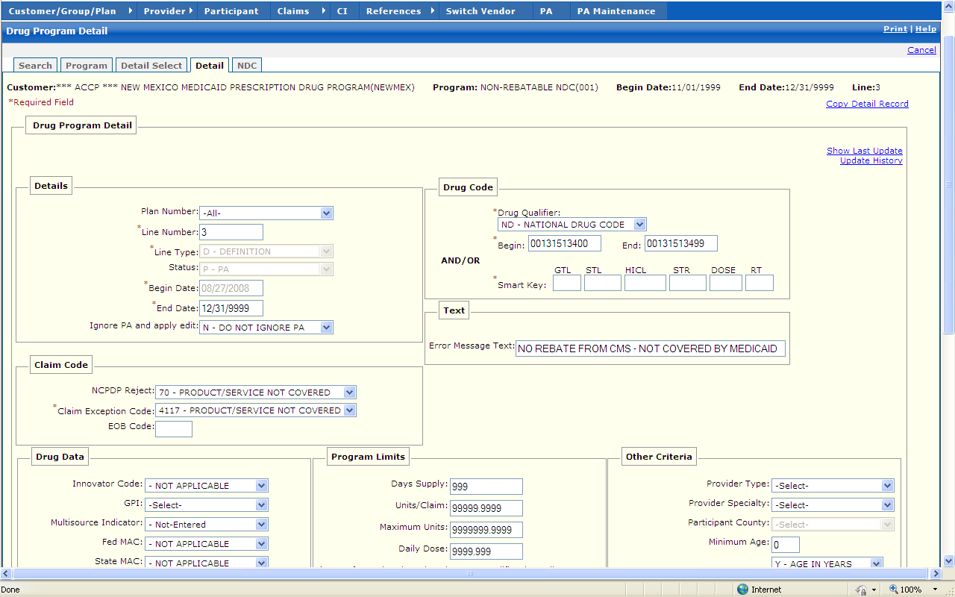

New Mexico PDCS OS PLUS Reference Subsystem
Window Exhibit
Drug Program Functional Group
Detail Tab Page
Field Name | Table Column Name | Table Name | Format | Prot. (A,C,N) | Req.  (A,C,N) | Std. Edits | Specifications |  | Note  Ref.
Customer | R_CUST_NAM & R_CUST_ID | R_CUST_DTL_TB | Display | A | N | N/A | This field is populated based on the Customer ID chosen upon login.
Program | A_PA_PROG_CD | A_PROG_DESC_TB | Display | A | N | N/A | This field is populated based on Drug Program chosen.
Begin Date | A_LI_BEG_DT | A_PROG_DEF_TB | Display | A | N | N/A
End Date | A_LI_BEG_DT | A_PROG_DEF_TB | Display | A | N | N/A
Line | A_LI_PROG | A_PROG_DEF_TB | Display | A | N | N/A | This field is populated based on line chosen.
Copy Detail Record | N/A | N/A | Link | N | N | N/A | When selected, a new Detail window is opened to copy the current program detail record.
Drug Program Detail | N/A | N/A | Free Form | N/A | N/A | N/A | Grouping
Show Last Update | G_AUD_USER_ID, G_AUD_TS | A_PROG_DEF_TB | X (20),  TIMESTAMP | N | N | N/A | By selecting the Show Last Update Link, a pop-up window is displayed showing User ID, Date and Time of when the record was last updated.
Details | Group | N/A | Free Form | N/A | N/A | N/A | Grouping
Plan Number | R_PLAN_ID | A_PROG_DEF_TB | Drop-down | N | N | N/A | Defaults to “All”
Line Number | A_PA_PROG_LI_NUM | A_PROG_DEF_TB | S9(4) | N | A
Line Type | A_PA_PROG_EXC_CD | A_PROG_DEF_TB | Drop-down | N | A | V | Valid Value list 0372
Status | A_LI_PROG_STAT_CD | A_PROG_DEF_TB | Drop-down | N | N | V | Defaults to “PA”  Valid value list 3891
Begin Date | A_LI_BEG_DT | A_PA_PDCS_TB | DATE | A | A | D | This field is always required if any other data is entered on the row. Format is MM/DD/CCYY. Must be a valid date. |  | R1
End Date | A_LI_END_DT | A_PA_PDCS_TB | DATE | A | A | D | This field is always required if any other data is entered on the row.  Format is MM/DD/CCYY. Must be a valid date. |  | R1
Ignore PA and apply edit | A_PROG_OVRD_IND | A_PROG_DEF_TB | Dropdown |  |  |  | Valid Values List 2679
Drug Code | Group | N/A | Free Form | N/A | N/A | N/A | Grouping
Drug Qualifier | A_RNGE_TY_CD | A_PROG_DEF_TB | Drop-down | N | A | V | Valid Value list 5927
Begin | R_DRUG_GCN_CD | A_PA_PDCS_TB | X (5) | N | A | N/A | Allows GCN, NDC, GSN, GTL
End | R_DRUG_GCN_CD | A_PA_PDCS_TB | X (5) | N | N | N/A
AND/OR | Group | N/A | Free Form | N/A | N/A | N/A
Smart Key: | Group | N/A | Free Form | N/A | N/A | N/A | Grouping
GTL | R_SK_GENR_THERA_CD | A_PROG_DEF_TB | X (2) | A | N | N/A
STL | R_SK_SPEC_THERA_CD | A_PROG_DEF_TB | X (4) | A | N | N/A
HICL | R_SK_HICL_CD | A_PROG_DEF_TB | X (5) | A | N | N/A
STR | R_SK_STREN_CD | A_PROG_DEF_TB | X (4) | A | N | N/A
DOSE | R_SK_DS_CD | A_PROG_DEF_TB | X (3) | A | N | N/A
RT | R_SK_RT_CD | A_PROG_DEF_TB | X (2) | A | N | N/A
Text | Group | N/A | Free Form | N/A | N/A | N/A | Grouping
Error Message Text | A_ERR_MSG_TX | A_PROG_DEF_TB | X (50) | N | N | N/A
Claim Code | Group | N/A | Free Form | N/A | N/A | N/A | Grouping
NCPDP Reject | R_CLM_ADJUD_REJ_CD | A_PROG_DEF_TB | Drop-down | N | N | V | Valid values list 4453
Claim Exception Code | R_CLM_EXC_CD | A_PROG_DEF_TB | X (4) | A | A | V | Created from NDCDP reject selected. These are not valid values, they are retrieved from the exception code tables.
EOB Code | R_TXT_EOB_CD | A_PROG_DEF_TB | X (4) | N | N | V | These are not valid values; they are retrieved from the exception code tables.
Drug Data | Group | N/A | Free Form | N/A | N/A | N/A | Grouping
Innovator Code | A_INNOVATOR_IND | A_PROG_DEF_TB | Drop-down | N | N | V | Valid values list 4544
GPI | R_DRUG_GEN_PRD_CD | A_PROG_DEF_TB | Drop-down | N | N | V | Valid values list 1839
Multisource Indicator | R_DRUG_GENR_IND | A_PROG_DEF_TB | Drop-down | N | N | V | Valid values list 1841
Fed MAC | A_FMAC_ON_FILE_IND | A_PROG_DEF_TB | Drop-down | N | N | V | Valid values list 3329
State MAC | A_SMAC_ON_FILE_IND | A_PROG_DEF_TB | Drop-down | N | N | V | Valid values list 6911
Drug Form | R_DRUG_FM_CD | A_PROG_DEF_TB | Drop-down | N | N | V | Valid values list 1833
Drug Class | R_DRUG_CLS_CD | A_PROG_DEF_TB | Drop-down | N | N | V | Valid values list 1814
Unit Dose Code | R_DRUG_UNT_DOSE_CD | A_PROG_DEF_TB | Drop-down | N | N | V | Valid values list 1885
Drug Category | R_DRUG_CAT_CD | A_PROG_DEF_TB | Dropdown |  |  |  | Valid Values List 311
Drug Route | C_DRUG_ROUTE_CD | A_PROG_DEF_TB | Dropdown |  |  |  | Valid Values List 872
Program Limits | Group | N/A | Free Form | N/A | N/A | N/A | Grouping
Days Supply | A_MAX_DAY_SPLY_NUM | A_PROG_DEF_TB | 9(3) | N | N | N | Default to 999
Units/Claim | A_MAX_CLM_UNIT_LMT | A_PROG_DEF_TB | 9(9) V99 | N | N | N | Default to 99999.9999
Maximum Units | A_MAX_UNIT_LMT | A_PROG_DEF_TB | 9(11) V99 | N | N | N | Default to 999999.9999
Daily Dose | A_MAX_DLY_DOSE_AMT | A_PROG_DEF_TB | 9(7) V99 | N | N | N | Default to 9999.999
Cost/Claim | A_MAX_DLR_CLM_AMT | A_PROG_DEF_TB | 9(7) V99 | N | N | N | Default to 999999.99
Number Refills | R_MAX_REFILL_NUM | A_PROG_DEF_TB | SMALLINT | N | N | N | Default to 9999
Maximum Cost | A_MAX_DLR_AMT | A_PROG_DEF_TB | 9(7) V99 | N | N | N | Default to 9999.99
Duration | R_DUR_SPAN_NUM | A_PROG_DEF_TB | SMALLINT | N | N | N | Default to 0
Span Type | R_DUR_UNIT_SPAN_CD | A_PROG_DEF_TB | X (1)  Drop-down | N | N | V | Valid Values list 7537
Other Criteria | Group | N/A | Free Form | N/A | N/A | N/A | Grouping
Provider Type | P_TYP_CD | A_PROG_DEF_TB | Drop-down | N | N | V | Valid values list 7537
Provider Specialty | P_SPECL_CD | A_PROG_DEF_TB | Drop-down | N | N | V | Valid values list 2653
Participant County | G_ADR_CNTY_CD | A_PROG_DEF_TB | X (3) | N | N | V | Valid Values List 8204
Minimum Age | A_MIN_AGE  A-MIN-AGE-CD | A_PROG_DEF_TB  A_PROG_DEF_TB | SMALLINT  Drop Down | N  N | N  N | N  N | Default to 00  Y = min. age in Years  M = min. age in Months
Maximum Age | A_MAX_AGE | A_PROG_DEF_TB | SMALLINT | N | N | N | Default to 999
Gender | B_GENDER_CD | A_PROG_DEF_TB | Drop-down | N | N | V | Valid values list 0229
Nursing Home | A_NH_IND | A_PROG_DEF_TB | Drop-down | N | N | V | Valid values list 6553
Hospice | A_HSPC_IND | A_PROG_DEF_TB | Drop-down | N | N | V | Valid values list 9384
Pregnancy | A_PRGNCY_IND | A_PROG_DEF_TB | Drop-down | N | N | V | Valid values list 2526
Provider Sub-specialty | P_SUB_SPECL_CD | A_PROG_DEF_TB | Drop- Down |  |  |  | Not specified in Valid Values list
Diagnosis Code | Group | N/A | Free Form | N/A | N/A | N/A | Grouping
Diagnosis Code | R_DIAG_CD | A_PROG_DEF_TB | X (7) | N | N | N/A
From | R_DIAG_BEG_CD | A_PROG_DEF_TB | Date
To | R_DIAG_END_CD | A_PROG_DEF_TB | Date
Command Buttons | Group | N/A | Button Row | N/A | N/A | N/A | Grouping
Add | N/A | N/A | Push Button | N | N | N/A | Adds current Diagnosis code record.
Update | N/A | N/A | Push Button | N | N | N/A | Updates current Diagnosis code record
Delete | N/A | N/A | Push Button | N | N | N/A | Deletes current Diagnosis code record
Command Buttons | Group | N/A | Button Row | N/A | N/A | N/A | Grouping
Previous Line | N/A | N/A | Push Button | N | N | N/A | Previous Line Button moves to presentation of the previous Drug Program record.
Next Line | N/A | N/A | Push Button | N | N | N/A | Next Line Button moves to presentation of the Next Drug Program record.
Update | N/A | N/A | Push Button | N | N | N/A | Updates current Drug Program record.
Delete | N/A | N/A | Push Button | N | N | N/A | Deletes current Drug Program record.
Save | N/A | N/A | Push Button | N | N | N/A | Updates current Drug Program record.

Legend
Prot. and Req. | Standard Edits | Note Ref.
A = Always | D = Date Edit | C = Customer-specific field or functionality
C = Conditionally | N = Numeric Edits | R = Note Reference
N = Never | S = System Generated
 | V = Valid Value Edit

Ref. No. | Notes
R1 | End Date must be greater than Begin Date. If not, the following error message is displayed: “The End Date is before the Begin Date. Change one of the Dates.”

New Mexico PDCS OS PLUS Reference Subsystem
Window Specification
Drug Program Functional Group
NDC Tab Page

Window Name:
Drug Program: NDC

Description:
The NDC window displays a list of NDCs (drugs) that are included in a selected Drug Program. The user may search for a specific drug or drug class by using the “Search by” function at the bottom. The user may search by NDC, TxCl, GSN, or GCN.

Window Type:
Response window

Navigation:
The user enters this window by 1) selecting a Drug Program from the Search window, 2) selecting a plan from the Detail Select window, and 3) clicking on the NDC tab while in the Drug Program functional group of the PDCS OS PLUS Reference subsystem.

Interface to Other Subsystem(s):
N/A

Interface to Other Application(s):
N/A

Special Security Requirements:
Add, Update, and Delete functionality is restricted to authorized users.

Presentation Sequence(s):
N/A

Remarks:
N/A

New Mexico PDCS OS PLUS Reference Subsystem
Window Layout
Drug Program Functional Group
NDC Tab Page

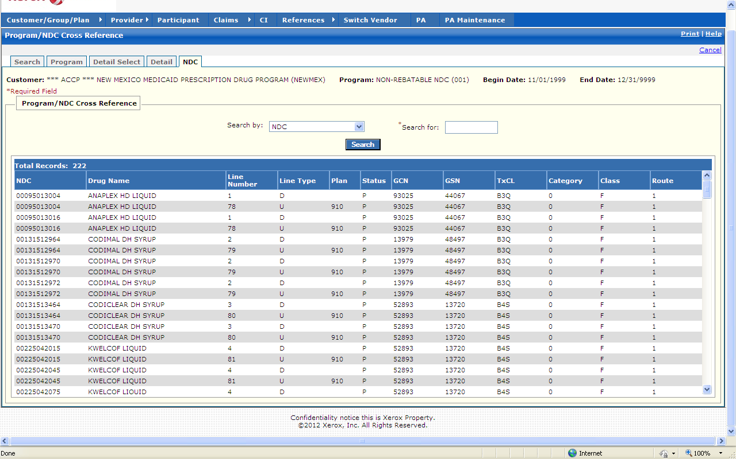

New Mexico PDCS OS PLUS Reference Subsystem
Window Exhibit
Drug Program Functional Group
NDC Tab Page
Field Name | Table Column Name | Table Name | Format | Prot.  (A, C, N) | Req.  (A, C, N) | Std. Edits | Specifications | Note  Ref.
Customer | R_CUST_NAM & R_CUST_ID | R_CUST_DTL_TB | Display | A | N | N/A | This field is populated based on the Customer ID chosen upon login.
Program | A_PA_PROG_CD | A_PROG_DESC_TB | Display | A | N | N/A | This field is populated based on Drug Program chosen.
Begin Date | A_LI_BEG_DT | A_PROG_DEF_TB | Display | A | N | N/A
End Date | A_LI_BEG_DT | A_PROG_DEF_TB | Display | A | N | N/A
Program/NDC Cross Reference Display | Group | N/A | Free Form | N/A | N/A | N/A | Grouping
NDC | R_DRUG_CD | A_PROG_XREF_TB | X (11) | A | N | N/A |  | R1
Drug Name | R_DRUG_NAM | R_DRUG_TB | X (30) | A | N | N/A
Line Number | A_PA PROG_LI_NUM | A_PROG_DEF_TB | X (4) | A | N | N/A
Line Type | A_PA_PROG_EXC_CD | A_PROG_DESC_TB | X (12) | A | N | N/A | Valid values list 0372
Plan | R_PLAN_ID | A_PROG_XREF_TB | X (3) | A | N | N/A
Status | A_HDR_STAT_CD | A_PROG_XREF_TB | X (1) | A | N | N/A | Valid values list 0164
GCN | R_DRUG_GCN_CD | A_PA_PDCS_TB | X (5) | A | N | N/A
GSN | A_GSN_NUM | A_PA_PDCS_TB | X (6) | A | N | N/A
TxCL | A_THERA_CD | A_PA_PDCS_TB | X (3) | A | N | N/A
Category | R_DRUG_CAT_CD | A_PROG_DEF_TB | X (5) | A | N | N/A | Valid values list 0311
Class | R_DRUG_CLS_CD | A_PROG_DEF_TB | X (1) | A | N | N/A | Valid values list 1814
Route | C_DRUG_ROUTE_CD | R_DRUG_TB | X (1) | A | N | N/A | Valid values list 0872
Total Records | N/A | N/A | N/A | A | N | N/A
Program/NDC Cross Reference Entry | Group | N/A | N/A | N/A | N/A | N/A | Grouping
Search by | N/A | N/A | Drop-down | N | N | V | Search default: NDC. Other options include TxCL, GSN, GCN.  Valid values 3003
Search for | N/A | N/A | N/A | N | A | N/A | This field is required. A % can be used as a wildcard along with 3 characters.
Command Button | Group | N/A | Button Row | N/A | N/A | N/A | Grouping
Search | N/A | N/A | Push Button | N | N | N/A | When selected, this button searches the Drug Program database to match the criteria entered in the Search By and the Search For criteria fields.

Legend
Prot. and Req. | Standard Edits | Note Ref.
A = Always | D = Date Edit | C = Customer-specific field or functionality
C = Conditionally | N = Numeric Edits | R = Note Reference
N = Never | S = System Generated
 | V = Valid Value Edit

Ref. No. | Notes
R1 | If a Drug Program Detail includes more than 500 NDCs, an error message posts at the top of the NDC tab window alerting the user to this fact. Only 500 NDC records may be viewed at once.

13.2.7.6 Step Care Functional Group

This functional group provides the user the ability to:

- Inquire on step care information

Note: The Step Care functional group is not currently utilized for New Mexico.

The following tab windows are used by the Step Care Functional Group:

- Search
- Step Care
- Agents

The following data is displayed in the title bar of all tab windows in this functional group:

- Customer
New Mexico PDCS OS PLUS Reference Subsystem
Window Specification
Step Care Functional Group
Search Tab Page

Window Name:
Step Care: Search

Description:
The Search window allows a user to search for a Step Care protocol by Drug Code, Plan ID, or Status.

The Step Care functional group is not currently utilized for New Mexico.

Window Type:
Response window

Navigation:
The user enters this window by clicking on the Step Care functional group drop-down list of the PDCS OS PLUS Reference subsystem.

Interface to Other Subsystem(s):
N/A

Interface to Other Application(s):
N/A

Special Security Requirements:
Add, Update, and Delete functionality is restricted to authorized users.

Presentation Sequence(s):
The Search By criteria determines the initial sequence of data presented. The search results may be re-sorted into Drug ID, Begin Date, End Date, Plan ID, Group ID, Template or Status sequence by clicking on the column heading.

Remarks:
N/A

New Mexico PDCS OS PLUS Reference Subsystem
Window Layout
Step Care Functional Group
Search Tab Page

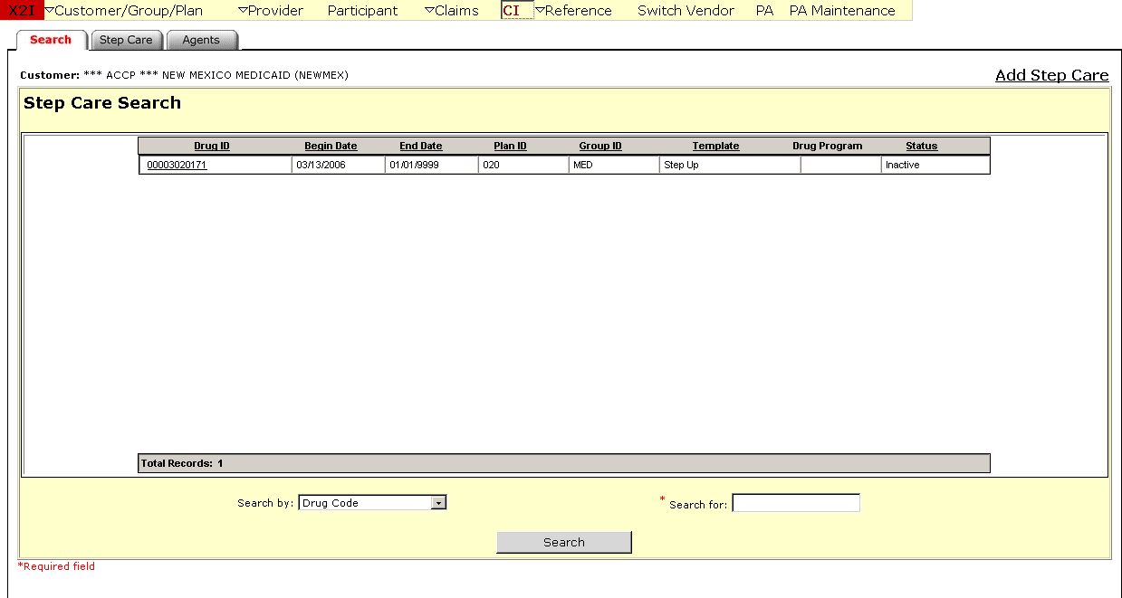

New Mexico PDCS OS PLUS Reference Subsystem
Window Exhibit
Step Care Functional Group
Search Tab Page
Field Name | Table  Column Name | Table Name | Format | Prot.  (A,C,N) | Req.  (A,C,N) | Std. Edits | Specifications | Note  Ref.
Customer | R_CUST_NAM & R_CUST_ID | R_CUST_DTL_TB | Display | A | N | N/A | This field is populated based on the Customer ID chosen upon login.
Add Step Care | N/A | N/A | Link | N/A | N/A | N/A | When selected, a blank New Step Care Wizard tab window is opened to add a new Step Care protocol.
Step Care Search Display | Group | N/A | Grid | N/A | N/A | N/A | Grouping
Drug ID | A_DRUG_ID_CD | A_STP_CARE_MSTR_TB | X (1) | A | N | N/A
Begin Date | A_SC_DRUG_BEG_DT | A_STP_CARE_MSTR_TB | X (10) | A | N | N/A
End Date | A_SC_DRUG_END_DT | A_STP_CARE_MSTR_TB | X (10) | A | N | N/A
Plan ID | R_PLAN_ID | A_STP_CARE_MSTR_TB | X (3) | A | N | N/A
Group ID | R_GROUP_ID | A_STP_CARE_MSTR_TB | X (8) | A | N | N/A | A valid group on the PDCS OS PLUS Group Table.
Template | A_TMPLT_ID | A_STP_CARE_MSTR_TB | X (1) | A | N | N/A | Value of “1” only  Valid values list 8940
Drug Program | A_PA_PROG_CD | A_STP_CARE_MSTR_TB | X (12) | A | N | N/A
Status | A_STAT_CD | A_STP_CARE_MSTR_TB | X (1) | A | N | N/A | Identifies the action PDCS OS PLUS takes when finding a historical claim: A-active, E-exclude, or I-ignore.
Total Records | N/A | N/A | Display | A | N | N/A | Computed.
Step Care Search Entry | Group | N/A | N/A | Free Form | N/A | N/A | Grouping
Search by | N/A | N/A | Drop-down | N | N | V | Search default: Drug Code.  Other search values: Plan ID and Status.  Valid Values List 5205
Search for | N/A | N/A | N/A | N | A | N/A | This field is required. A % can be used as a wildcard along with 3 characters.
Command Button | Group | N/A | Button Row | N/A | N/A | N/A | Grouping
Search | N/A | N/A | Push Button | N | N | N/A | When selected, this button searches the Step Care database to match the criteria entered in the Search By and the Search For criteria fields.

Legend
Prot. and Req. | Standard Edits | Note Ref.
A = Always | D = Date Edit | C = Customer-specific field or functionality
C = Conditionally | N = Numeric Edits | R = Note Reference
N = Never | S = System Generated
 | V = Valid Value Edit

Ref. No. | Notes
N/A | N/A
New Mexico PDCS OS PLUS Reference Subsystem
Window Specification
Step Care Functional Group
Step Care Tab Page

Window Name:
Step Care: Step Care

Description:
The Step Care window displays basic information about the Step Care protocol. The basic information includes status, dosage limitations, begin date and end date, and the corresponding NCPDP reject, claim exception code, and error message text that is sent to the dispensing provider when a claim denies due to a Step Care protocol.

The Step Care functional group is not currently utilized for New Mexico.

Window Type:
Response window

Navigation:
The user enters this window by selecting a Step Care program from the Search window. The Step Care window is located in the Step Care functional group of the PDCS OS PLUS Reference subsystem.

Interface to Other Subsystem(s):
N/A

Interface to Other Application(s):
N/A

Special Security Requirements:
Add, Update, and Delete functionality is restricted to authorized users.

Presentation Sequence(s):
N/A

Remarks:
N/A

New Mexico PDCS OS PLUS Reference Subsystem
Window Layout
Step Care Functional Group
Step Care Tab Page

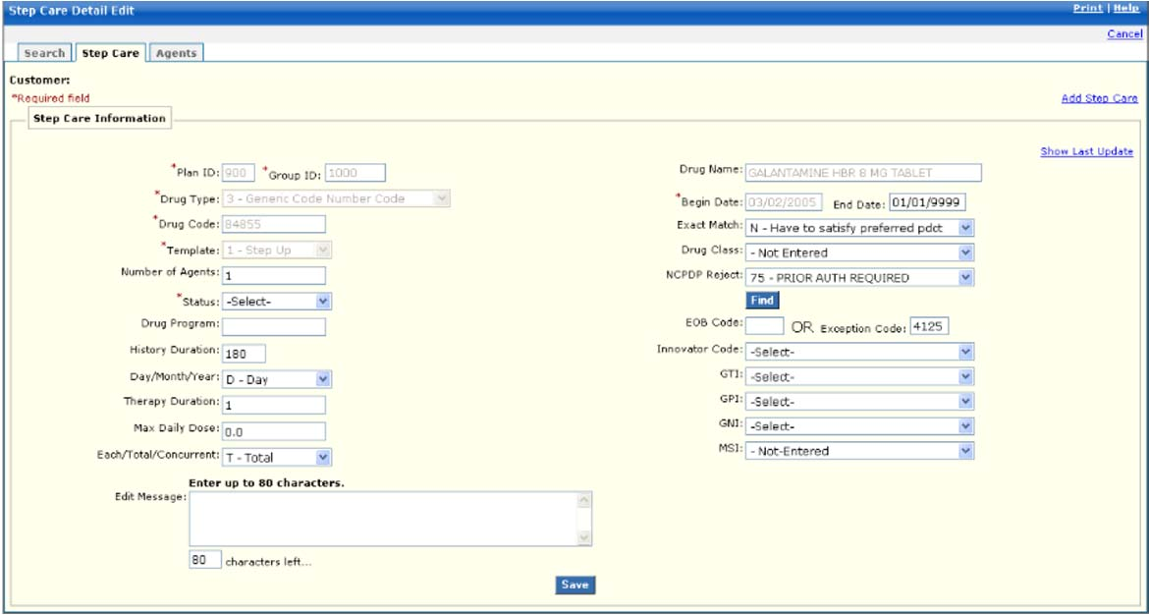

New Mexico PDCS OS PLUS Reference Subsystem
Window Exhibit
Step Care Functional Group
Step Care Tab Page
Field Name | Table  Column Name | Table Name | Format | Prot.  (A,C,N) | Req.  (A, C, N) | Std. Edits | Specifications | Note  Ref.
Customer | R_CUST_NAM & R_CUST_ID | R_CUST_DTL_TB | Display | A | N | N/A | This field is populated based on the Customer ID chosen upon login.
Add Step Care | N/A | N/A | Link | N/A | N/A | N/A | When selected, a blank New Step Care Wizard window is opened to add a new Step Care protocol.
Step Care Information | Group | N/A | Free Form | N/A | N/A | N/A | Grouping
Show Last Update | G_AUD_USER_ID, G_AUD_TS | A_STP_CARE_MSTR-TB | Link | N | N | N/A | By selecting the Show Last Update Link, a pop-up window is displayed showing User ID, Date and Time of when the record was last updated.
Plan ID | R_PLAN_ID | A_STP_CARE_MSTR-TB | X (3) | N | A | N/A
Group ID | R_GROUP_ID | A_STP_CARE_MSTR-TB | X (8) | N | A | N/A | A valid group on the PDCS OS PLUS Group Table.
Drug Type | R_DRUG_PRC_TY_CD | R_DRUG_PRC_TB | X (3) | N | A | V | Valid values list 8998
Drug Code | R_DRUG_CD | R_DRUG_CONTRA_TB | X (11) | N | A | N/A
Template | A_TMPLT_ID | A_STP_CARE_MSTR_TB | X (1) | N | A | V | Value of “1” only  Valid values list 8940
Number of Agents | A_AGNT_CNT_NUM | A_STP_CARE_MSTR_TB | X (4) | N | N | N | The number of different agents a patient must have tried in history to meet the protocol to receive a step care product.
Status | A_STAT_CD | A_STP_CARE_MSTR_TB | X (1) | N | A | V | Identifies the action PDCS OS PLUS takes when finding a historical claim: A-active, E-exclude or I-ignore.  Valid values list 5205
Drug Program | A_PA_PROG_CD | A_STP_CARE_MSTR_TB | X (12) | N | N | N/A
History Duration | A-HIST-SPN-NUM | A-STP-CARE-MSTR-TB | X (4) | N | N | N/A | The number used to determine how far in history PDCS OS PLUS searches for patient claims related to the drug identifier in days, months or years.
Day/Month/Year | N/A | N/A | Drop-down | N | N | N/A | D-days, M-months, Y-years
Therapy Duration | A-THPY-SPN-NUM | A-STP-CARE-MSTR-TB | X (4) | N | N | N | Identifies how long a patient must have maintained therapy on specific drugs in history. Value = length in days.
Max Daily Dose | A_MAX_DLY_DOSE_AMT | A_STP_CARE_MSTR_TB | X (7) | N | N | N/A
Each/Total/  Concurrent | A_EA_TOT_CD | N/A | Drop-down | N | N | V | Valid values list 5609
Edit Message | A_TXT_EOB_TX | A_STP_CARE_MSTR_TB | X (80) | N | N | N/A | The specific message to be sent to the pharmacy regarding how the claim is to be handled, suggesting alternate therapy or a reason the patient does not meet the criteria.
Characters left | N/A | N/A | N/A | N | N/A | N/A | Computed
Drug Name | R_DRUG_NAM | R_DRUG_PRC_TB | X (30) | N | C | N/A
Begin Date | A_SC_DRUG_BEG-_DT | A_STEP_CARE_DTL_TB | X (10)  Date | A | A | D | This field is always required if any other data is entered on the row. Format is MM/DD/CCYY. Must be a valid date. | R1
End Date | A_SC_DRUG_END_DT | A_STP_CARE_MSTR_TB | X (10)  Date | A | C | D | This field is always required if any other data is entered on the row. Format is MM/DD/CCYY. Must be a valid date. | R1
Exact Match | A_EXACT_MTCH_IND | A_STP_CARE_MSTR_TB | X (1) | N | N | N/A | Set the indicator to bypass the normal step-care processing.
Drug Class | R_DRUG_CLS-_CD | A_STP_CARE_MSTR_TB | X (1) | N | N | V | Valid values list 1840
NCPDP Reject | R_CLM_EXC_CD | A_STP_CARE_MSTR_TB | X (4) | N | N | V | Valid values list 1737
Command Button | Group | N/A | Button Row | N/A | N/A | N/A | Grouping
Find | N/A | N/A | Push Button | N/A | N/A | N/A | Locates the selected NCPDP Reject Code
EOB Code | R_TXT_EOB_CD | R-CLM-EXC-EOB-TB | X (4) | N | N | N/A
Exception Code | R_CLM_EXC_CD | A_STP_CARE_MSTR_TB | (4) | N | N | N/A
Innovator Code | R_INNOVATOR_LOC_CD | A_STP_CARE_MSTR_TB | X (1) | N | N | V | Valid values list 5699
GTI | R_GENR_THERA_IND | N/A | Drop-down | N | N | V | Valid values list 5609
GPI | R_DRUG_GEN_PRD_CD | N/A | Drop-down | N | N | V | Valid values list 1839
GNI | R_GENR_NAME_IND | N/A | Drop-down | N | N | V | Valid values list 4642
MSI | R_DRUG_GENR_IND | N/A | Drop-down | N | N | V | Valid values list 1841
Command Button | Group | N/A | Button Row | N/A | N/A | N/A | Grouping
Save | N/A | N/A | Push Button | N/A | N/A | N/A | Saves any changes to the Step Care protocol record.

Legend
Prot. and Req. | Standard Edits | Note Ref.
A = Always | D = Date Edit | C = Customer-specific field or functionality
C = Conditionally | N = Numeric Edits | R = Note Reference
N = Never | S = System Generated
 | V = Valid Value Edit

Ref. No. | Notes
R1 | End Date must be greater than Begin Date. If not, the following error message is displayed: “The End Date is before the Begin Date. Change one of the Dates.”

New Mexico PDCS OS PLUS Reference Subsystem
Window Specification
Step Care Functional Group
Agents Tab Page

Window Name:
Step Care: Agents

Description:
The Agents window displays a list of preferred agents associated with a Step Care protocol, and any dosage limitations if applicable.

The Step Care functional group is not currently utilized for New Mexico.

Window Type:
Response window

Navigation:
The user enters this window by clicking on the Agents tab, after selecting a Step Care protocol from the Search window. The Agents window is located in the Step Care functional group of the PDCS OS PLUS Reference subsystem.

Interface to Other Subsystem(s):
N/A

Interface to Other Application(s):
N/A

Special Security Requirements:
Add, Update, and Delete functionality is restricted to authorized users.

Presentation Sequence(s):
N/A

Remarks:
N/A

New Mexico PDCS OS PLUS Reference Subsystem
Window Layout
Step Care Functional Group
Agents Tab Page

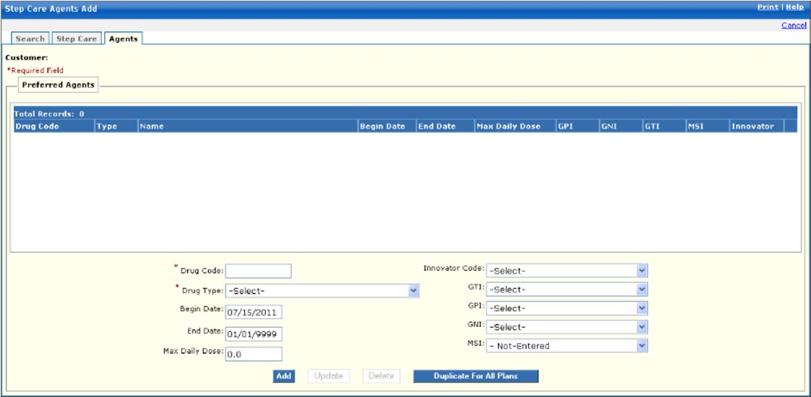

New Mexico PDCS OS PLUS Reference Subsystem
Window Exhibit
Step Care Functional Group
Agents Tab Page
Field Name | Table  Column Name | Table Name | Format | Prot.  (A,C,N) | Req.  (A,C,N) | Std. Edits | Specifications | Note  Ref.
Customer | R_CUST_NAM & R_CUST_ID | R_CUST_DTL_TB | Display | A | N | N/A | This field is populated based on the Customer ID chosen upon login.
Preferred Agents Display | Group | N/A | Grid | N/A | N/A | N/A | Grouping
Drug Code | R_DRUG_CD | R_DRUG_CONTRA_TB | X (11) | A | N | N/A
Type | R_DRUG_PRC_TY_CD | R_DRUG_PRC_TB | X (3) | A | N | N/A | Valid values list 8998
Name | R_DRUG_NAM | R_DRUG_PRC_TB | X (30) | A | N | N/A
Begin Date | A_SC_DRUG_BEG-_DT | A_STEP_CARE_DTL_TB | DATE | A | N | N/A
End Date | A_SC_DRUG_END_DT | A_STP_CARE_MSTR_TB | X (10) | A | N | N/A
Max Daily Dose | A_MAX_DLY_DOSE_AMT | A_STP_CARE_MSTR_TB | X (7) | A | N | N/A
GPI | R_DRUG_GEN_PRD_CD | A_STP_CARE_MSTR_TB | Drop-down | A | N | N/A | Valid values list 1839
GNI | R_GENR_NAME_IND | A_STP_CARE_MSTR_TB | Drop-down | A | N | N/A | Valid values list 4642
GTI | R_GENR_THERA_IND | A_STP_CARE_MSTR_TB | Drop-down | A | N | N/A | Valid values list 5609
MSI | R_DRUG_GENR_IND | A_STP_CARE_MSTR_TB | Drop-down | A | N | N/A | Valid values list 1841
Innovator | R_INNOVATOR_LOC_CD | A_STP_CARE_MSTR_TB | X (1) | A | N | N/A | Valid values list 5699
Preferred Agents Entry | Group | N/A | Free Form | N/A | N/A | N/A | Grouping
Drug Code | A_DRUG_ID_CD | A_STEP_CARE_DTL_TB | X (1) | N | A | N/A |  | R1
Drug Type | R_DRUG_PRC_TY_CD | R_DRUG_PRC_TB | X (3) | N | A | V | Valid values list 8998 | R1
Begin Date | A_SC_DRUG_BEG-_DT | A_STEP_CARE_DTL_TB | DATE | A | C | D | Must be a valid date
End Date | A_SC_DRUG_END_DT | A_STP_CARE_MSTR_TB | DATE  X (10) | A | C | D | Must be a valid date
Max Daily Dose | A_MAX_DLY_DOSE_AMT | A_STP_CARE_MSTR_TB | X (7) | N | N | N/A
Innovator Code | R_INNOVATOR_LOC_CD | A_STP_CARE_MSTR_TB | X (1) | A | N | V | Valid values list 5699
GTI | R_GENR_THERA_IND | N/A | Drop  Down | N | N | V | Valid values list 5609
GPI | R_DRUG_GEN_PRD_CD | N/A | Drop  Down | N | N | V | Valid values list 1839
GNI | R_GENR_NAME_IND | N/A | Drop  Down | N | N | V | Valid values list 4642
MSI | R_DRUG_GENR_IND | N/A | Drop  Down | N | N | V | Valid values list 1841
Command Buttons | Group | N/A | Button Row | N/A | N/A | N/A | Grouping
Add | N/A | N/A | Push Button | N | N | N/A | When Add Button is selected, a new record is created based on data entered in the Preferred Agents window.
Update | N/A | N/A | Push Button | N | N | N/A | When Update Button is selected and a preferred agent row is highlighted, the row can be changed and updated.
Delete | N/A | N/A | Push Button | N | N | N/A | When Delete Button is selected and a Preferred Agent row is displayed, the row is deleted.
Duplicate For All Plans | N/A | N/A | Push Button | N | N | N/A | When the Duplicate for All Plans button is selected, the Preferred Agent in the display boxes is copied to all Plans.

Legend
Prot. and Req. | Standard Edits | Note Ref.
A = Always | D = Date Edit | C = Customer-specific field or functionality
C = Conditionally | N = Numeric Edits | R = Note Reference
N = Never | S = System Generated
 | V = Valid Value Edit

Ref. No. | Notes
R1 | Based on the Drug Code that is entered, the Drug Type must be a valid combination. For example, if an NDC is entered in Drug Code, then the Drug Type must be 1-National Drug Code, if a GSN is keyed, the Drug Type must be 2-Generic Sequence Number Code. If an invalid combination is entered, the following error message is generated and displayed: The drug type and code combination are not valid.

13.2.7.7 Inferred Disease Functional Group

This functional group provides the user the ability to:

- Inquire on inferred disease information

Note: The Inferred Disease functional group is not currently utilized for New Mexico. For this reason, Window Exhibits are not provided for this functional group.

New Mexico PDCS OS PLUS Reference Subsystem
Window Specification
Inferred Disease Functional Group
Search Tab Page

Window Name:
Inferred Disease: Search
Description:
The Inferred Disease Search tab window is the first window that appears when the Inferred Disease functional group is selected from the Reference subsystem menu. Any existing Inferred Disease display automatically. The user may also search for a particular inferred disease record using specified criteria.

Note: The Inferred Disease functional group is not currently utilized for New Mexico.

Window Type:
Response window
Navigation:
The user enters this window by clicking the Reference option on the PDCS OS PLUS menu, then clicking the Inferred Disease option. This displays the Inferred Disease Search window. The user may add a new Inferred Disease record or may select a record for detail viewing by clicking on the Disease Code link.
Interface to Other Subsystem(s):
N/A
Interface to Other Application(s):
N/A
Special Security Requirements:
Add, Update, and Delete functionality is restricted to authorized users.
Presentation Sequence(s):
Inferred Diseases are presented by Disease Code order.
Remarks:
N/A
New Mexico PDCS OS PLUS Reference Subsystem
Window Layout
Inferred Disease Functional Group
Search Tab Page

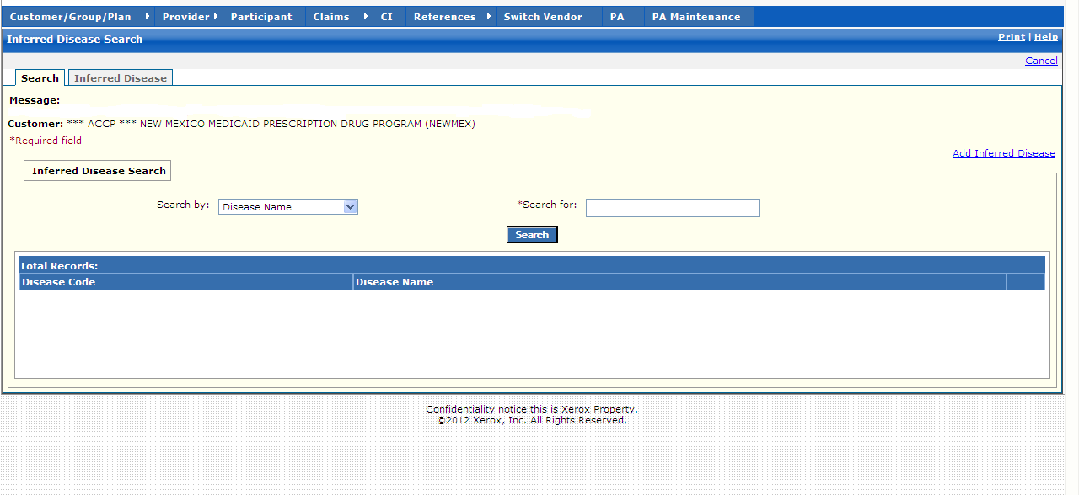

New Mexico PDCS OS PLUS Reference Subsystem
Window Specification
Inferred Disease Functional Group
Inferred Disease Tab Page

Window Name:
Inferred Disease: Inferred Disease
Description:
The Inferred Disease Information window appears after clicking the Add Disease link or selecting an existing Inferred Disease record.

Note: The Inferred Disease functional group is not currently utilized for New Mexico.

Window Type:
Response window
Navigation:
The user enters this window by clicking the Add Disease link or selecting an existing Inferred Disease record.
Interface to Other Subsystem(s):
N/A
Interface to Other Application(s):
N/A
Special Security Requirements:
Add, Update, and Delete functionality is restricted to authorized users.
Presentation Sequence(s):
N/A
Remarks:
N/A

New Mexico PDCS OS PLUS Reference Subsystem
Window Layout
Inferred Disease Functional Group
Inferred Disease Tab Page

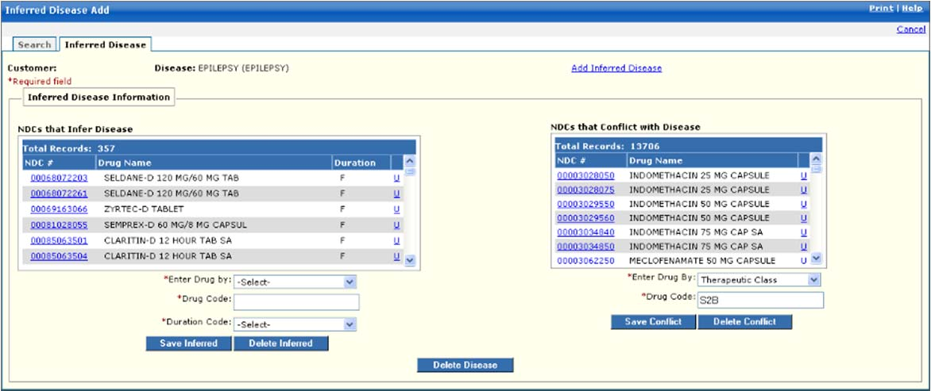

13.2.7.8 DUR Functional Group

This functional group provides the user the ability to:

- Inquire on DUR information

The following tab windows are used by the DUR Functional Group:

- Search
- DUR

The following data is displayed in the title bar of all tab windows in this functional group:

- Customer

New Mexico PDCS OS PLUS Reference Subsystem
Window Specification
DUR Functional Group
Search Tab Page

Window Name:
DUR: Search

Description:
The Search window allows the user to search for Drug Utilization Review (DUR) codes by Therapeutic Class Code Spec or Generic Code Number.

Window Type:
Response window

Navigation:
The user enters this window by selecting the DUR functional group from the drop-down menu list of the PDCS OS PLUS Reference subsystem.

Interface to Other Subsystem(s):
N/A

Interface to Other Application(s):
N/A

Special Security Requirements:
Add, Update, and Delete functionality is restricted to authorized users.

Presentation Sequence(s):
The Search By criteria determines the initial sequence of data presented. The search results may be resorted into Drug Type and Drug Code by clicking on the column heading.

Remarks:
Parameters are not updateable in this window.

New Mexico PDCS OS PLUS Reference Subsystem
Window Layout
DUR Functional Group
Search Tab Page

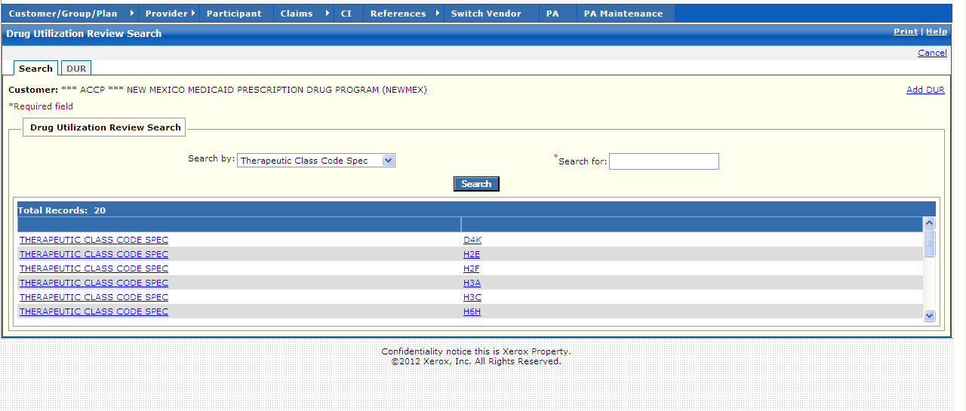

New Mexico PDCS OS PLUS Reference Subsystem
Window Exhibit
DUR Functional Group
Search Tab Page
Field Name | Table Column Name | Table Name | Format | Prot.  (A, C, N) | Req.  (A, C, N) | Std. Edits | Specifications | Note  Ref.
Customer | R_CUST_NAM & R_CUST_ID | R_CUST_DTL_TB | Display | A | N | N/A | This field is populated based on the Customer ID chosen upon login.
Add DUR | N/A | N/A | Link | N/A | N/A | N/A | When selected, a blank DUR tab window is opened to create a new DUR record.
Drug Utilization Review Search | N/A | N/A | Free Form | N/A | N/A | N/A | Grouping
Drug Type | R_HCFA_DRUG_TY_CD | R_DRUG_TB | X (1) | A | N | N/A | Valid values list 4376
Drug Code | R-THERA-GENR-CD | R_DRUG_DUR_  FLTR_TB | X (1) | A | N | N/A
Total Records | N/A | N/A | N/A | A | N | N/A | Computed
Drug Utilization Review Search Entry | Group | N/A | N/A | N/A | N/A | N/A | Grouping | .
Search by | N/A | N/A | Drop-down | N | N | V | Search default: Therapeutic Code Class Spec. Other search is Generic Code Number.  Valid Values 5406
Search for | N/A | N/A | N/A | N | A | N/A | This field is required. A % can be used as a wildcard along with 3 characters.
Command Button | Group | N/A | Button Row | N/A | N/A | N/A | Grouping
Search | N/A | N/A | Push Button | N | N | N/A | When selected, this button searches DUR database to match the criteria entered in the Search By and the Search For criteria fields.

Legend
Prot. and Req. | Standard Edits | Note Ref.
A = Always | D = Date Edit | C = Customer-specific field or functionality
C = Conditionally | N = Numeric Edits | R = Note Reference
N = Never | S = System Generated
 | V = Valid Value Edit

Ref. No. | Notes
N/A | N/A

New Mexico PDCS OS PLUS Reference Subsystem
Window Specification
DUR Functional Group
DUR Tab Page

Window Name:
DUR: DUR

Description:
The DUR window displays basic DUR information by conflict code. Age, unit, and day supply limitations, with severity level, are displayed where applicable.

Window Type:
Response window

Navigation:
The user enters this window by clicking the DUR tab of the DUR functional group within the PDCS OS PLUS Reference subsystem, or by selecting a Drug Type or Drug Code from the DUR Search window.

Interface to Other Subsystem(s):
N/A

Interface to Other Application(s):
N/A

Special Security Requirements:
Add, Update, and Delete functionality is restricted to authorized users.

Presentation Sequence(s):
N/A

Remarks:
N/A

New Mexico PDCS OS PLUS Reference Subsystem
Window Layout
DUR Functional Group
DUR Tab Page

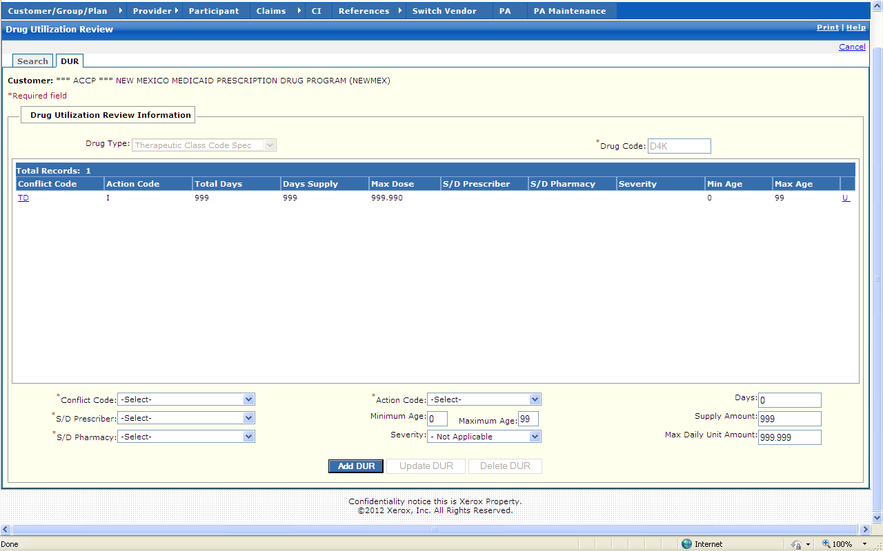

New Mexico PDCS OS PLUS Reference Subsystem
Window Exhibit
DUR Functional Group
DUR Tab Page
Field Name | Table Column Name | Table Name | Format | Prot.  (A, C, N) | Req.  (A, C, N) | Std. Edits | Specifications | Note  Ref.
Customer | R_CUST_NAM & R_CUST_ID | R_CUST_DTL_TB | Display | A | N | N/A | This field is populated based on the Customer ID chosen upon login.
Drug Utilization Review Information | N/A | N/A | Free Form | N/A | N/A | N/A | Grouping
Drug Type | R_HCFA_DRUG_TY_CD | R_DRUG_TB | X (1)  Drop-down | A | N | V | Valid values list 4376
Drug Code | R_THERA-GENR-CD | R_DRUG_DUR_  FLTR_TB | X (1) | A | A | N/A
Drug Utilization Review Information Display | N/A | N/A | Grid | N/A | N/A | N/A | Grouping
Conflict Code | R_RSN_FOR_SVC_CD | R_DRUG_DUR_  FLTR_TB | X (2) | A | N | N/A | Valid values list 4376
Action Code | R_DUR_ADJUD_IND | R_DRUG_DUR_  FLTR_TB | X (1) | A | N | N/A | Valid values list 6410
Total Days | R_TOT_DAYS_NUM | R_DRUG_DUR_  FLTR_TB | X (3) | A | N | N/A
Days Supply | R_PD_DAYS_SPLY_AMT | R_DRUG_DUR_  FLTR_TB | X (3) | A | N | N/A
Max Dose | R_MAX_DLY_UNT_AMT | R_DRUG_DUR_  FLTR_TB | X (7) | A | N | N/A
S/D Prescriber | R_S_D_PRESCR_IND | R_DRUG_DUR_  FLTR_TB | X (1) | A | N | N/A | Valid values list 6510
S/D Pharmacy | R_S_D_PHARM_IND | R_DRUG_DUR_  FLTR_TB | X (1) | A | N | N/A | Valid values list 3977
Severity | R_DUR_SVRTY_CD | R_DRUG_DUR_  FLTR_TB | X (1) | A | N | N/A | Valid values list 5614
Min Age | R_MIN_AGE | R_DRUG_DUR_  FLTR_TB | X (3) | A | N | N/A
Max Age | R_MAX_AGE | R_DRUG_DUR_  FLTR_TB | X (3) | A | N | N/A
Total Records | N/A | N/A | Display | A | N | N/A | Computed as total number of records meeting the search criteria.
Drug Utilization Review Information Entry | N/A | N/A | N/A | N/A | N/A | N/A | Grouping
Conflict Code | R_RSN_FOR_SVC_CD | R_DRUG_DUR_  FLTR_TB | Drop-down | N | A | V | Valid values list 8605
S/D Prescriber | R_S_D_PRESCR_INC | R_DRUG_DUR_  FLTR_TB | Drop-down | N | A | V | Valid values list 6510
S/D Pharmacy | R_S_D_PHARM_IND | R_DRUG_DUR_  FLTR_TB | Drop-down | N | A | V | Valid values list 3977
Action Code | R_DUR_ADJUD_IND | R_DRUG_DUR_  FLTR_TB | Drop-down | N | A | V | Valid values list 6410
Minimum Age | R_MIN_AGE | R_DRUG_DUR_  FLTR_TB | 999 | N | N | N
Maximum Age | R_MAX_AGE | R_DRUG_DUR_  FLTR_TB | 999 | N | N | N
Severity | R_DUR_SVRTY_CD | R_DRUG_DUR_  FLTR_TB | Drop-down | N | N | V | Valid values list 5614
Days | R_PD_DAYS_SPLY_AMT | R_DRUG_DUR_  FLTR_TB | 999 | N | N | N
Supply Amount | R_PD_DAYS_SPLY_AMT | R_DRUG_DUR_  FLTR_TB | 999 | N | N | N
Max Daily Unit Amount | R_MAX_DLY_UNT_AMT | R_DRUG_DUR_  FLTR_TB | 9,999.999 | N | N | N
Command Buttons | Group | N/A | Button Row | N/A | N/A | N/A | Grouping
Add DUR | N/A | N/A | Push Button | N | N | N/A | When the Add DUR Button is selected, a new record is created based on data entered in the DUR Entry boxes at the bottom of the window and added.
Update DUR | N/A | N/A | Push Button | N | N | N/A | When Update DUR Button is selected and a DUR entry is displayed at the bottom of the window, the displayed row can be changed and updated.
Delete DUR | N/A | N/A | Push Button | N | N | N/A | When the DUR Delete Button is selected and a DUR row is displayed at the bottom of the window, the displayed row is deleted.

Legend
Prot. and Req. | Standard Edits | Note Ref.
A = Always | D = Date Edit | C = Customer-specific field or functionality
C = Conditionally | N = Numeric Edits | R = Note Reference
N = Never | S = System Generated
 | V = Valid Value Edit

Ref. No. | Notes
N/A | N/A

